Global Active Directory consolidation and standardisation - HUSQVARNA

Document ID | AD 001
Version | 1.2
Version Date | 19/05/2017
Lead Architect | Shaik Meera Saheb
Project Manager
Project Sponsor

Table of Contents
1 Introduction 5
1.1 Purpose 5
1.2 In Scope for AD Consolidation 5
1.3 Out of Scope 7
1.4 In Scope for AD Stabilization 8
1.5 Dependencies and Constraints 8
1.6 Audience 8
1.7 Glossary of Terms 9
2 Architecture Overview 11
2.1 The Microsoft Active Directory Technology 11
2.2 Active Directory Deployments within HUSQVARNA 11
2.3 Active Directory and Core Services Technologies Overview 12
2.4 Architectural Considerations 13
2.4.1 HUSQVARNA Architecture Principles 13
2.4.2 Architectural Outcomes 14
2.4.3 Architecture Considerations for the Legacy Active Directory 14
2.4.4 Problems 14
2.4.5 Opportunities 15
2.5 Architecture Highlights 16
2.5.1 Solution Highlights 16
2.5.2 New Features 17
3 Functional Requirements 17
3.1 Summary of Key Requirements 17
3.1.1 Audit Requirements 17
3.1.2 Compliance Requirements 17
3.1.3 Integration Requirements 18
3.1.4 Maintenance Requirements 21
3.1.5 Monitoring Requirements 22
3.1.6 Security Requirements 22
4 Non-Functional Requirements 22
4.1 Security Requirements 22
4.2 Change Cases 23
5 Active Directory Design for Legacy consolidation 23
5.1 Forest and Domain Structure – Production Corporate AD 24
5.2 Migration Approach 26
5.3 Migration Tool 29
5.4 List of Domains and Status 31
5.5 Distributed File System 34
6 Global Domain Stabilization Design 35
6.1 Future Road Map 35
6.2 What is being changed 35
6.3 Forest and Domain Trusts 35
6.4 Domain Controllers 35
6.5 Active Directory Sites and Services 38
6.6 DNS Design 40
6.7 DHCP Servers 41
6.8 Sensitive Groups 42
6.9 Organisational Unit Structure 44
6.10 Group Policies 48
6.11 PKI Design 51
7 DEPENDENCIES 52
8 Test cases and Acceptance 52
9 RACI 52
10 Appendix 53

Version History

Version | Version Date | Change Description | Author
1.0 | 22/10/2016 | First draft | Meera Saheb Shaik
1.1 | 15/05/2017 | Added DFS and PKI | Arunkumar Gajendiran
1.2 | 19/05/2017 | Updated the details discussed in PPT version | Meera / Arun

Introduction
Active Directory is a Microsoft technology that provides a set of commonly used network services, such as user authentication, access control, and policy enforcement. It is Microsoft’s implementation of a network directory, and is a core technology leveraged by many applications and services.
Husqvarna first implemented Active Directory many years back. Since this original deployment, the Active Directory platform has grown both organically and via acquisitions. As a result the current Active Directory environment outgrown its original design specifications, and become fragmented as the directory environments from acquired companies are not integrated.
HUSQVARNA engaged HCL to review the environment and advise on the best way forward. The main recommendation of the assessment, HUSQVARNA to consolidate all legacy to global corporate Active Directory Taking this approach reduces time to deliver the solution, reduces risk to HUSQVARNA’s systems during the transition, and facilitates the rapid adoption of new technologies. HUSQVARNA has decided to adopt this recommendation and the Active Directory programme was started with this objective.
This solution architecture details the end-state architecture of the Active Directory solution, and provides a high level overview of how transition will be achieved. The actual migration has its own requirements and will also detailed the solution architecture.
Once the target state is achieved, HUSQVARNA will have a single consolidated Active Directory platform that is based on modern technology and is fit for purpose. This will be an ideal platform for further expansion and business growth.

Purpose
The purpose of this solution architecture is to describe a new global corporate Active Directory consolidation for the purpose of consolidating all HUSQVARNA corporate Active Directory environments across the globe. This Migration will help in future to achieve the single forest Single domain Model for Husqvarna.
This solution architecture covers Active Directory and supporting infrastructure services infrastructure, and includes legacy domains across the regions within the deployment scope. This includes the production Active Directories for HUSQVARNA and standardisation with best industry practices. Deployment of the solution will be staged. The initially, covered by a Pilot of two location France (Fry.Lan) and UK (Flentdom.Local) and will follow subsequently.

In Scope for AD Consolidation
This solution is intended to provide a fully featured directory service capability to support standard corporate users with Windows 7 clients, including client server applications hosted on Windows Servers.
- Decommissioning of existing 57 Legacy production Active Directories, including removal of interoperability/co-existence environments (includes interim trusts, migration tools and processes);
- Migration of all resources from Legacy domain to Global
- Assessment of Legacy domain infrastructure
- Assessment report
- Planning the site migration schedule
- Production testing and piloting
- Production migration
- Communicate the list of applications with Husqvarna SPOC/application team
- Co-ordinate with SPOC/application team for the application remediation
- Migrate the DNS zones from the legacy domains to the Global DNS Servers
- Migrate the DHCP servers from the legacy domains to the Global domain
- Migrate the file servers and reACL the file servers
- Create the required site links.
- Design the AD topology for the better replication model.
- OU Level delegation for the existing support groups with the limited access to manage the resources.

The following technologies are within the scope of the Legacy AD consolidation
Subject Area | Technology
Directory Services | Forests, domains, OUs (Organisational Units)
Name Resolution | Domain Name System (DNS)
Network Services | Dynamic Host Configuration Protocol (DHCP)  Network Time Protocol (NTP)
Table 1 – In Scope Technology
The scope of this Solution Architecture for Legacy consolidation includes consideration of the 57 domains and following existing Active Directory environments assessment completed and listed with number of active servers/Users/Workstation at the time of assessment taken as shown below:
Site Name | Domain Name | Report Active Users/Computers Using <=60 Days Summary |  |  |  | Migration Scope
Site Name | Domain Name | Active Servers | Active DC's | Active Users | Client OS | Migration Scope
Huskvarna, Sweden/multi-site & Huskvarna, Sweden | dimas-ad.local | 2 | 1 | 7 | 3 | Migration Activity done via  ADMT &  Generic Method  Domain Controller, Member servers,  File servers , Application Servers
Huskvarna, Sweden/multi-site & Huskvarna, Sweden | dw.ext.hvwan.net | 12 | 2 | 118 | 0
Huskvarna, Sweden/multi-site & Huskvarna, Sweden | se2.hvwan.net | 2 | 2 | 8 | 1
Huskvarna, Sweden/multi-site & Huskvarna, Sweden | SE.hvwan.net | 96 | 5 | 253 | 415
Huskvarna, Sweden/multi-site & Huskvarna, Sweden | timtestad.hvwan.net | 17 | 3 | 14 | 1
Ulm, Germany /Multi-site | gardena.com | 2 | 2 | 9 | 1
Ulm, Germany /Multi-site | gde.gardena.com | 162 | 7 | 236 | 86
Charlotte (US)/multi-site | Beatrice.Electrolux-na.com | 7 | 3 | 11 | 1
Charlotte (US)/multi-site | hcc.ca.hvwan.net | 7 | 2 | 11 | 0
Charlotte (US)/multi-site | hcop.us.hvwan.net | 68 | 8 | 130 | 55
Charlotte (US)/multi-site | huskyclt.com | 22 | 2 | 36 | 26
Columbia (US) | columbia.cp.electrolux-na.com | 3 | 3 | 29 | 17
McRae (US)/multi-site | cp.electrolux-na.com | 9 | 2 | 37 | 8
France | Fry.Lan | 4 | 2 | 5 | 1
Aycliffe, UK | Flentdom.Local | 23 | 2 | 44 | 11
UK/ multi-site | uk.hvwan.net | 3 | 2 | 13 | 0
Kawagoe, Japan | jp.hvwan.net | 5 | 2 | 21 | 15
Kawagoe, Japan | pc.zenoah.kmtg.net | 9 | 2 | 334 | 164
Shanghai, China/multi-site | DIAMANT-BOART.COM.CN | 3 | 2 | 11 | 6
Shanghai, China/multi-site | jfs.com | 3 | 2 | 14 | 1
Vbrno & Bruntal, Czech Republic | advplast.cz | 5 | 3 | 392 | 85
Vaerlose, Denmark | dk.hvwan.net | 2 | 2 | 7 | 1
Tallinn, Estonia | ee.hvwan.net | 2 | 1 | 6 | 0
Sofia, Bulgaria | ELECTROLUX.BG | 1 | 1 | 11 | 9
Hermanni, Finland | fi.hvwan.net | 3 | 2 | 7 | 0
Tuggerah, Australia | Husqau.lan | 5 | 2 | 15 | 2
Sao Paolo, Brazil/multi-site | husqvarna.com.br | 29 | 3 | 60 | 36
Warsaw, Poland | HUSQWAW.LOCAL | 2 | 1 | 21 | 4
Kokuszki, Poland | KOLUSZKI.POLSKA | 1 | 1 | 12 | 1
Kaunas, Lithuania | LT.HVWAN.NET | 2 | 1 | 7 | 1
Riga, Latvia | LV.HVWAN.NET | 2 | 1 | 18 | 0
Oslo, Norway | no.hvwan.net | 4 | 2 | 15 | 7
Mankau City, New Zealand | nz.electrolux.corp
 | GA.EXT.se.HVWAN.NET | 15 | 2 | 6 | 0
EMEA Construction Site | Cp.com | 4 | 2 | 16 | 3
 | Diamant-boart.com | 13 | 6 | 35 | 13
Table 2 – Assessment completed Legacy Environments

Out of Scope
The following are out of scope of this solution architecture, but not out of scope of the HUSQVARNA Active Directory solution overall. Each will be addressed subsequently during the program:
- User, groups and workstation are not part of migration scope but HCL will assist Husqvarna while migration of user
- Any license management for migration will be out of scope
- There will be several other unidentified applications in legacy domains that requires modification to support co-existence phase so those applications need to be remediate by respective application owner and HCL will assist from infra stand point
- Application migration and remediation however the list of applications will be communicated by HCL and the co-ordination with application SPOC from Husqvarna.

In Scope for AD Stabilization
- Stabilizing the identified GAP’s in the Global Environment as mentioned in section 6.2
- Work with internal teams and get the required inputs.
- Plan and mitigate the risks before implementing the identified GAP’s.
- Follow the change process to implement the task.
- Re-verification of the ADRAP and ADRES report and necessary actions based on the existing inputs.
- Best industry practice for Global AD Domain and Recommendations with Task List Tracker which includes
  - Review and Creating new best practice Domain Design
  - Review and Creating new best practice DNS Design for Active Directory
  - Review and Creating new best practice on an Organizational Unit Design
  - Review and Creating new best practice Site Topology
  - Review and Creating new best practice for user access groups

Dependencies and Constraints
The known dependencies for this solution are as follows.
Dependent Initiative | Inbound or Outbound | Nature of dependency
Application Remediation | Inbound | For migrated servers and applications.
DNS | Inbound | Legacy servers should point to Global DNS
DHCP | Inbound | Migration of DHCP Scope or associated servers to Global
Time service | Inbound | Time service integration for migrated servers
Table 3 - Dependencies

Audience
The following table identifies the audience of this document.
Audience | Intended purpose
Business Stakeholder | High-level understanding.  Provide non-technical audience with a broad understanding of the solution’s architecture.
Enterprise and Domain Architecture | Architecture Alignment.  To ensure alignment with Enterprise and Domain Architectures and standards.
Project Team | Project Planning.  To support ongoing project planning.
Peer Reviewers | Peer Socialisation/Review.  To understand the context of the activity and solution being proposed in order to provide objective feedback through the Peer Review & Ratification processes.
Security, Risk and Compliance | Risk Management.  To ensure the architecture addresses Risk and Compliance issues.
Detailed Designers | Next Phase Handover.  Provide architectural context for the detailed design.
Table 4 - Audience

Glossary of Terms
This Solution Architecture uses the following naming convention to differentiate between Windows Server 2012 and Windows Server 2012 R2 operating system versions:
- Windows Server 2012 (this version of Windows only)
- Windows Server 2012 R2 (this version of Windows only)
- Windows Server 2012/R2 (both versions of Windows)
Where necessary, operating system may be appended with (32 bit) or (64 bit) to identify the operating system address space architecture. However, Windows Server 2012 R2 has only a 64-bit version - there is no 32-bit version available. Therefore within this solution architecture Windows Server 2012 R2 always refers to the 64 bit edition.
In this solution architecture, definitions specific to the project are:
Acronym | Phrase
AD CS | Active Directory Certificate Services
AD DS | Active Directory Domain Services
AD FS | Active Directory Federation Services
ADSI | Active Directory Service Interfaces
CA | Certificate Authority
DC | Domain Controller
DDNS | Dynamic Domain Name Service
DFS | Distributed File System
DFS-R | Distributed File System Replication
DHCP | Dynamic Host Configuration Protocol
DL | Distribution List
DMZ | De-Militarised Zone
DRP | Disaster Recovery Plan
FIM | Forefront Identity Manager
FRS | File Replication Service
FSMO | Flexible Single Master Operations
GAL | Global Address List
GC | Global Catalogue
GPMC | Group Policy Management Console
GPO | Group Policy Object
ICMP | Internet Control Message Protocol
ISTG | Inter-Site Topology Generator
KCC | Knowledge Consistency Checker
KDC | Kerberos Key Distribution Centre
KMS | Key Management Service
LAN | Local Area Network
LDAP | Lightweight Directory Access Protocol
MTU | Maximum Transfer Unit
NPS | Network Policy Server
NPAS | Network Policy and Access Services
OCS | Office Communications Server
OU | Organisational Unit
PCNS | Password Change Notification Service
PDC | Primary Domain Controller
PKI | Public Key Infrastructure
RADIUS | Remote Authentication Dial-In User Service
RID | Relative Identifier
SCCM | System Centre Configuration Manager
SCOM | System Centre Operations Manager
WINS | Windows Internet Naming Service
WAN | Wide Area Network
Table 5 - Acronyms Definitions

Architecture Overview

The Microsoft Active Directory Technology
Active Directory is Microsoft’s implementation of an LDAP-compliant directory. It provides authentication (though usernames and passwords), authorisation (through security group membership) and auditing (through security policy configuration). It also provides the storage and replication engine for Active Directory-integrated applications (e.g. DNS, Exchange, OCS, PKI, etc). It also provides the engine for the enforcement of defined security policies to users and computers through policy configuration mechanisms.
Many Microsoft and third party Windows applications leverage the functionality of Active Directory and within HUSQVARNA it is the foundation service for a managed Microsoft Windows Platform.

Active Directory Deployments within HUSQVARNA
The breadth and complexity of the existing HUSQVARNA Active Directory infrastructure, with its mixture of different forests and domains, all with varying security and operational standards, is a large contributing factor in the requirement for a new, consolidated global deployment. The existing environment has not been architected on the scale needed to deliver to HUSQVARNA’s ‘super-regional’ agenda that requires global consistency and access. This breadth and complexity significantly impacts the ability of the environment to respond to changes in the business, particularly acquisitions.
The diagram below depicts the current Active Directory forest/domain deployments used for production systems and it is intended to clearly demonstrate that HUSQVARNA’s rapid expansion and acquisition agenda is a clear contributing factor to the expanse of Active Directory deployments within scope of this program.
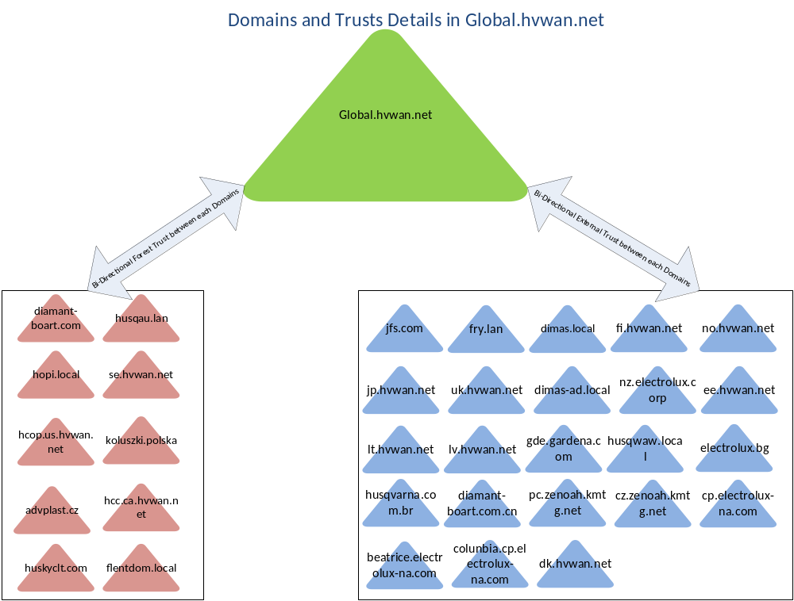
Figure 1 - Active Directory - Current Forests (Production)

Active Directory and Core Services Technologies Overview
As a technology, Active Directory requires a key set of supporting infrastructure that together forms the foundation services of a Windows platform. These core services include Domain Naming System (DNS), Dynamic Host Configuration Protocol (DHCP) and Windows Internet Naming Service (WINS). These key technologies are considered part of the core services technologies within an Active Directory deployment and are intentionally linked and grouped together within this solution architecture. Secondary technologies also presented within the solution include Network Policy Service (NPS) and Key Management Service (KMS), which are deployed to facilitate other functional requirements for authentication and licensing management.
The following figure shows a functional overview of the components making up the solution:
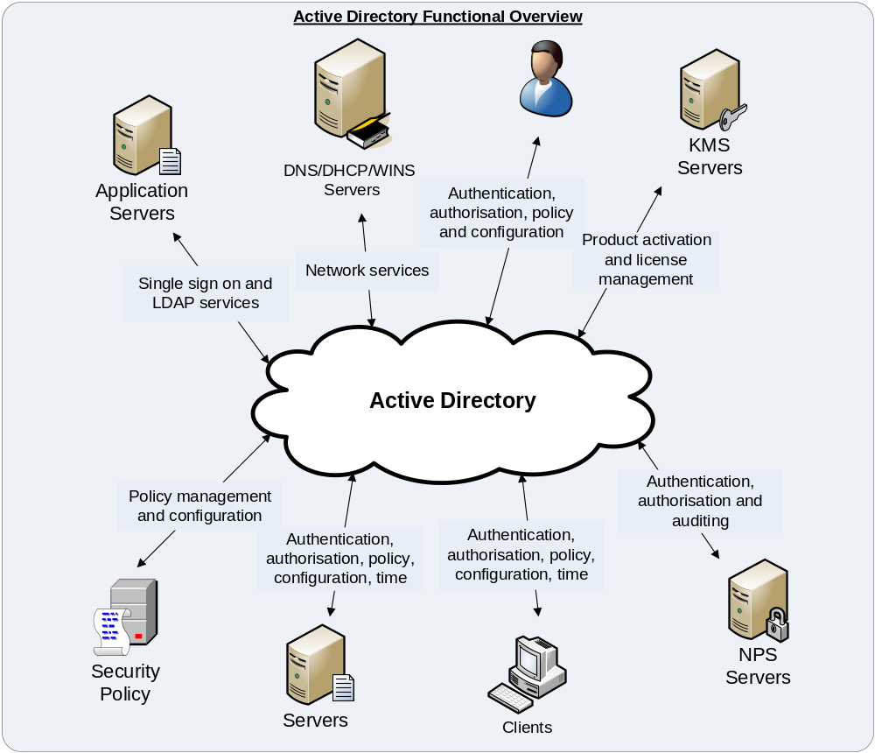
Figure 2 - Active Directory Functional Overview
The following table provides an overview of the key technologies included in this solution:
Technology | Overview
Active Directory | The Microsoft Active Directory infrastructure in a forest/domain environment is known as AD DS (Active Directory Domain Services). Active Directory provides the following key services to the Windows platform:  - Authentication  - Authorisation  - Network Directory  - Security Policy  Active Directory authenticates users, stores and serves directory data, and manages access to network resources. Through the use of Group Policy, Active Directory defines and enforces security policies on users and computers within the directory.  A domain controller is a server that is hosting Active Directory.
Domain Name System (DNS) | DNS is a key associated service within an Active Directory deployment and is required to provide standards-based hostname to IP-address resolution for network clients and servers. DNS is used by clients to find network resources.  This solution architecture describes the integration of DNS in the new global Active Directory environment, and its integration with the existing HUSQVARNA DNS hierarchy.
Dynamic Host Configuration Protocol (DHCP) | DHCP provides IP addressing and networking configuration to devices on the HUSQVARNA network. DHCP is therefore a key foundation of the network management stack, and is used throughout HUSQVARNA for IP address allocation to Windows clients and more recently servers.  DHCP services are loosely coupled to Active Directory, however within HUSQVARNA they are considered a core service that almost all Windows systems depend on, and hence are addressed within this solution.
Time Services | Time Services in an Active Directory environment is based on the Network Time Protocol (NTP). This service is used to ensure that all domain-joined machines have accurate time. The time service is fully integrated into Active Directory and is delivered from the domain controller platform.  This is an essential service as reliable time is required as part of the authentication process. Having a reliable time service also provides a benefit to security by ensuring that date & timestamps in file systems and audit logs are accurate.
Table 6 – Functional Overview
This solution is dependent upon the following services or components for its functionality:
Technology | Purpose
Local and Wide-Area network (LAN/WAN) | Provides communications infrastructure to the platform.
System Centre Configuration Manager (SCCM) | Provides systems management services to the platform, including operating system deployment, application management, security patching, configuration management, and reporting.
System Centre Operations Manager (SCOM) | Provides monitoring and alerting capabilities, and security event log aggregation.
Public Key Infrastructure (PKI) | Provides certificates used for authentication and application access.
Windows 2012 R2 Managed Server Operating Environment (MSOE) | Provides a standardised server platform.
Server Virtualisation | Provides virtualisation hosting infrastructure.
Table 7 – Dependent Components

Architectural Considerations
This section contains the architectural considerations influencing this solution.

HUSQVARNA Architecture Principles
The following points represent the key architectural principles that HUSQVARNA subscribes to. These are the foundation principles for all architecture solutions within HUSQVARNA:
- Consolidation of Multi-domain/forest environment causes complexity
- Consolidation of 57 Domains across globe
- Migrate member servers/Unmanaged Desktops /service accounts to GLOBAL domain.
- ADMT is used to migrate servers and other objects from all legacy domain to Global domain
- OU structure is required to manage migrated servers and other legacy objects.
- Best practice implementation and Standardization
- Simplification and shared platforms;
- Consolidate and centralise;
- Architect once, architect globally (i.e. standardisation);
- Build foundations for strategic capabilities;
- Strategic partnership with few vendors.
Creating system architectures that embody these standards will lead to reductions in operating costs, reductions in security exposures, flexibility and agility to implement changes as desired by business users.

Architectural Outcomes
The Solution design has adopted the above architectural principles, and following further consultation and requirements determination, has translated these into the following outcomes for the program as a whole. These are the key points to which architecture solutions within program are aligned:
Description | Moniker
Update the technologies used to extend the lifecycle as far as possible | Lifecycle
Rapidly adopt new technologies to deliver business value as soon as possible | Agility
Simplify management and operations, reduce complexity | Simplification, Automation
Allow HUSQVARNA to be more responsive to business changes | Mobility
Rapidly and efficiently incorporate acquisitions into HUSQVARNA | Acquisition
Improve the security posture | Security
Table 8 - Application Blueprint and Standards
From an Active Directory legacy domain consolidation perspective, the outcomes that must be met to satisfy the business are:
- There is a vastly reduced number of domain controllers compared to the existing corporate environment. This is consistent with the HUSQVARNA strategy of centralising and consolidating services to the data centre, and takes full advantage of the improvements available in WAN bandwidth, redundancy, and optimisation technologies.
- A secure Active Directory environment for the operation of Husqvarna Active Directory services for productive and significant performance.
- Ease to manage the domain objects/administer in the Global domain.
- OU level delegation the existing administrator’s/support groups to manage the resources in global AD.

Architecture Considerations for the Legacy Active Directory
The existing HUSQVARNA Active Directory was engineered long back with the following high level characteristics:
- Multiple Active Directory forest based on business needs.
- Geographic/political-based OU structure;
- Servers located in Branches across the globe operating as both domain controllers and application servers;
- Software deployment using group policy objects;
- Heavy duty use of group policies to set & enforce security configurations;

Problems
This design has resulted in the following problems:
- A large number of domains and domain controllers were deployed to provide Active Directory services to HUSQVARNA locations. The size of this deployment caused scalability issues within Active Directory. In addition, domain controllers in the remote locations also acted as application servers, significantly increasing complexity of security and support. The end result was one of having too many domain controllers, poor flexibility, low agility, high TCO and increased risk;
- The complex use of group policies impacted agility, significantly increasing time to deliver new application solutions into Active Directory without measurably improving security;
- Trusts were implemented between the environments, with the aim being to facilitate release management between the environments. However the principles of environmental segregation were not strictly followed, with the result being that applications were sometimes run in the wrong environment In addition, the environments were often not kept in a consistent state; sometimes invalidating testing;
- A large number of trusts were required to acquired assets for integration purposes. There are also multiple instances of identity synchronisation products in use;
- The multi domain structure, while reducing Active Directory replication traffic, significantly complicated cross-regional administration, and the lack of cross-regional domain controllers meant that users travelling between regions experienced slow logon times and poor performance;
- A wide range of point solutions were used for systems management and monitoring & alerting, with a high degree of customisation and ongoing maintenance required;
- The lack of ongoing lifecycle management resulted in gradual aging of the platform, to the point where Microsoft would no longer offer support. HUSQVARNA then had to enter into an expensive maintenance agreement with Microsoft to maintain support for the platform.

Opportunities
Since the original design, technology has advanced and the following opportunities have presented themselves:
- Single domain forest(s) ease to manage
- Reduction in the number of servers as we are decommissioning the legacy domain controllers and other not required server (Ex. Backup or whichever is not required to migrate and decommission as per the confirmation from IT SPOC)
- Resources and objects are available in the same domain for the applications are to use core AD functionalities e.g. authentication, accounts management, etc.
- A standardized Organizational Unit structure and use of a transparent Role Based Access Control (RBAC) which logically separates management of AD data and management of AD Service
- Currently 19 Domain Controllers available in the Global AD and would not require any additional Domain Controller until otherwise new site users are migrated, it will be discussed with stakeholders to take decision.
- WAN bandwidth has become progressively cheaper, faster and more reliable. Many HUSQVARNA sites now have redundant connectivity to an upstream site or data centre. In addition, WAN acceleration technology such as Riverbed lowers overall bandwidth requirements and improves application performance over wide-area networks. Taken together, these technologies facilitate aggressive consolidation to the data centre, and reduce the requirement for widely dispersed server infrastructure;
- Virtualisation has taken hold, allowing the segregation of server roles and applications within dedicated virtual machine OS instances, while allowing consolidation onto small numbers of servers. It is no longer necessary to deploy many physical servers to provide security or workload segregation;
- Internal improvements within Active Directory have improved scalability for large environments and vastly reduced replication traffic;
- Microsoft’s capabilities in the system management space have been greatly improved, and have wide ISV and 3rd party support as a platform.
This solution architecture re-architects the Active Directory solution incorporating current requirements, best-practices, and new technologies. The lessons learnt from the current architecture are fully incorporated, while new features available in the solution set are leveraged.

Architecture Highlights

Solution Highlights
The key highlights of this solution and their alignment to the considerations identified are as follows:
Architecture Highlight | Architectural Alignment
A new single domain forest was created in for HUSQVARNA corporate production called GLOBAL.HVWAN.NET. The creation of a new forest allows the rapid adoption of new technology without having to undertake a lengthy and risk prone upgrade of the existing platform. It also facilitates, via migration, a consolidation into a single domain forest – this represents current best-practice for Active Directory. The single domain model resolves the cross-regional performance and administration problems inherent in the legacy architecture, and thanks to improvements in the Windows operating system, is more efficient.  The overall outcome of this cornerstone decision is enhanced agility, consistent global performance, simplified management, and reduced operational cost once the target state is achieved. This is the ideal platform for HUSQVARNA’s super-regional ambitions. | Foundation for strategic capabilities  Agility  Simplification  Mobility
There is a vastly reduced number of domain controllers compared to the existing corporate environment. This is consistent with the HUSQVARNA strategy of centralising and consolidating services to the data centre, and takes full advantage of the improvements available in WAN bandwidth, redundancy, and optimisation technologies. | Agility  Simplification
New single domain forests is created to support development and testing. However, unlike the legacy environment, trusts will not be configured between environments. This will ensure that applications are deployed to the appropriate environment. A new release management process will ensure that releases are managed appropriately, and that the environments are maintained in a consistent state. | Simplification  Standardisation
Windows Server 2012 R2 will be used exclusively for all domain controllers. Being the most recent version available, this has the longest support lifecycle. It is a fully 64-bit operating system, and provides great improvements in performance and scalability. It is also the most secure Microsoft operating system available. | Lifecycle  Security
Active Directory will be configured at the Windows 2012 R2 functional level. This facilitates the immediate adoption of new technologies such as Microsoft Exchange and Lync, and supports a range of new features providing simplification, agility, and security benefits (see the following section for details). | Simplification  Agility  Security
The OU structures are reengineered, supporting centralised management of global core infrastructure and global application services at a global level, decentralised delegation to the country level for in-country users and resources, and structured build into production.  The OU structure will designed on the basis that the majority of administration will be performed at an in-country level. However, some countries may require sub-country (e.g. Business Unit) delegation. The requirements for this (if any) will need to be identified when the country takes control of their OU structure in the GLOBAL environment. Ideally, countries should move to a country based administration model; user administration at a sub country level should only be configured if required to comply with legal/regulatory requirements. | Simplification  Standardisation  Security
Group Policies are reengineered, taking a simplified approach and supporting more rapid application integration through standardised application profiling and integration processes. | Simplification  Agility  Security
Table 9 – Architectural Highlights

New Features
Windows Server 2012 R2 provides a large number of new features. HUSQVARNA will adopt many of these features. Each new feature improves the manageability, administrative capabilities and/or security of Active Directory. Some of these key features are:
Feature | Description | Architectural Alignment
Offline Domain Join | Allows a Windows 7 or Windows Server 2012 R2 machine to join Active Directory without contacting a domain controller. Also, the machine does not have to restart having changed state (e.g. from a workgroup to a member server). This facilitates rapid, low touch deployment of desktops and servers. | Agility  Simplification
Active Directory Recycle Bin | To quickly undo an accidental deletion of an Active Directory object. This reduces the duration of an outage and enhances recoverability. | Simplification
Active Directory Best Practices Analyser | Identifies deviations from best practices to help HUSQVARNA better manage the Active Directory deployment. | Simplification
Managed Service Accounts | Provides simplified management of service accounts, automatically changes service account passwords. | Simplification  Security
Table 30 – New Feature Highlights

Functional Requirements
Requirements workshops have been conducted to determine the functional requirements of Active Directory in HUSQVARNA. These functional requirements have been identified as the key business requirements with respect to infrastructure management. They are not a fully prescribed set of Active Directory functional features that are available with Windows Server 2012 R2.

Summary of Key Requirements
The following tables contain the identified functional requirements for this solution.

Audit Requirements
Business Requirement | Analysis
"The solution shall enable the capability to audit and report configuration changes to AD. | Current default domain controller’s policy already deployed in the new corporate global forest. This includes auditing policy.

Compliance Requirements
Business Requirement | Analysis
"The solution shall enable the mechanism that can check group policy compliance against Windows Server/Client Operational Standards. | Group policies including AGPM will allow for change control role based delegation and improved deployment methodology for group policy. Which is already in place.

Integration Requirements
Business Requirement | Analysis
The Legacy Active Directory DNS environment must be created in standalone DNS Servers | Conditional forwarder from Global domain
Provide a platform that is agile enough that HUSQVARNA can adopt new technologies which are heavily dependent upon the Active Directory (such as Microsoft’s new unified communications technologies) without being hampered by the size of the corporate Active Directory. | Number of DCs will be minimised.
Integrate with other related initiatives as required. | Integration as required
The new AD infrastructure must be compatible with the existing network and minimise network changes. | Reuse is made of the existing network where possible.

OU Structure Requirements in Global Domain
Current OU Structure for the migrated domains
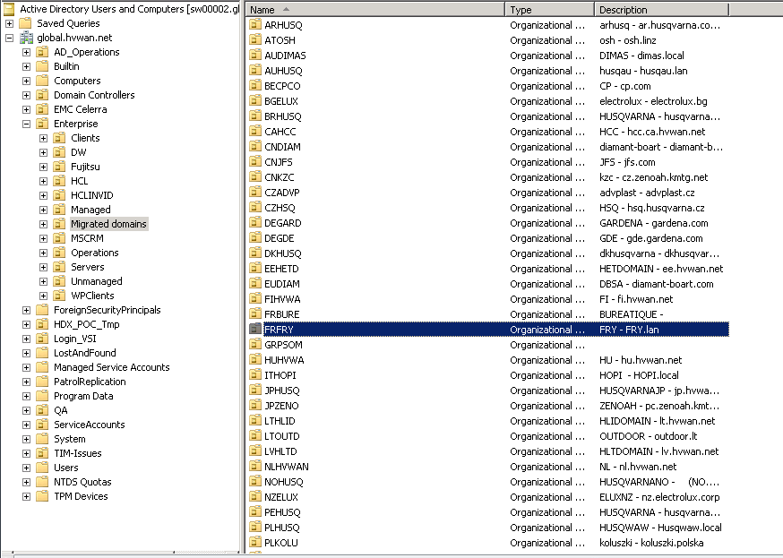

Finalised Organization unit structure for Legacy servers
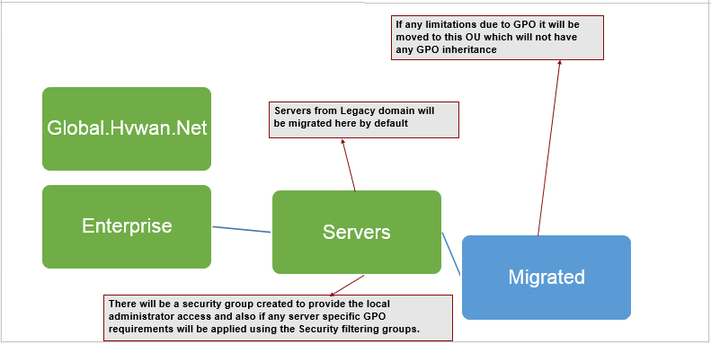

OU structure for service accounts and groups from Legacy domain
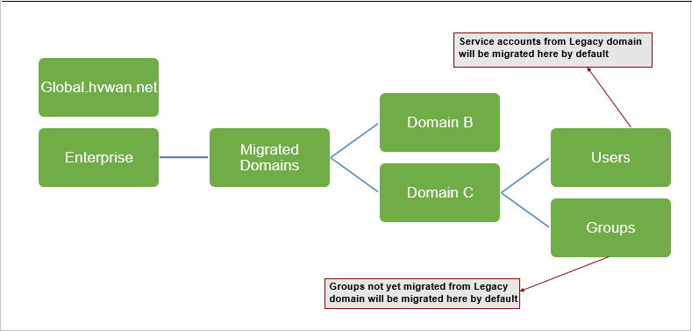

OU structure for Legacy OS Clients from migrated domains

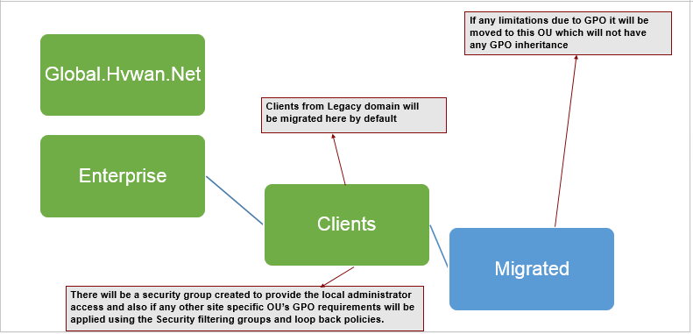

OU structure for WPS Clients
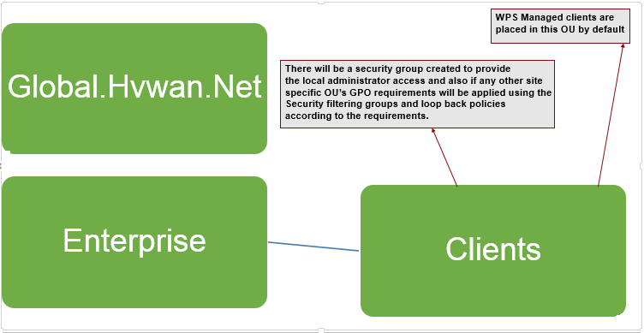

OU structure for Future development and testing
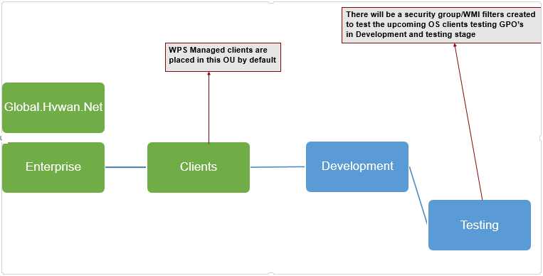

Maintenance Requirements
Business Requirement | Analysis
There must be the ability to version control Group Policy Objects. | Provided by the Microsoft Advanced Group Policy Management (AGPM).
The solution requires network time protocol source for time synchronization globally. | The PDC emulator of the global.Hvwan.net forest will synchronise time with the internal NTP server.
The architecture of the solution should lead to simplification of operational procedures. | The simplification will result from a consolidated domain.
Some operational procedures – especially those related to cross-forest and cross-domain moves – should be eliminated as a result consolidation of Legacy environment. | The simplification will result from a consolidated domain.
Group policies in the new forest must be operational and fulfil the requirement of legacy domains | Group policies will be defined and implemented in the new forest as needed.
The solution should provide the ability for end users to consume new technologies as soon as practical. | There will be dedicated DCs that do not host applications. Application servers i.e. Print services will not coexist on DCs. There will be vastly reduced numbers of DCs.
DHCP must support the ability to manage standard DHCP Scope options including management of PXE boot services. This will be adopted in the next phases. | Windows Server 2012 R2-based DHCP provides support for the required scope options to manage PXE boot services.
There must be the ability to dynamically update DNS. | The Active Directory-integrated DNS zone post consolidation supports secure dynamic update of DNS records.

Monitoring Requirements
Business Requirement | Analysis
There must be the ability to compare Group Policy Objects within a Forest. | Provided by the Microsoft Advanced Group Policy Management (AGPM)
There must be the ability to monitor all replication of the AD environment. | The AD management pack includes replication monitoring
There must be the ability to monitor the health of the AD environment. | The AD management pack monitors health
There must be the ability to monitor object access of Active Directory security. | This requirement will be addressed.

Security Requirements
Business Requirement | Analysis
Potential security exposures must be eliminated or reduced through simplification of the architecture. | A simplified architecture of a single corporate Active Directory without portioning it into domains at the moment, will significantly simplify the administration and management of the directory.

Non-Functional Requirements
Requirements workshops have been conducted to determine the non-functional requirements for this solution. The non-functional requirements for this solution are as follows:

Security Requirements
Business Requirement | Analysis
The AD Organisational Unit structure must support the Security Delegation Model requirements. | An appropriate AD delegation administration model will be developed.
There must be the ability for Group Policies to be migrated between Non production and Production environments. | The AGPM will facilitate this.
Non Production environments must support domain trust relationships | The only domain trusts that will exist are between the current non production forest and the corresponding non production forest.
The security configuration of Domain Controllers on virtual servers must match the security configuration for Domain Controllers on physical servers. | There is no plan to differentiate the security policies between physical and virtual DCs.
Core AD Services including DNS, & DHCP must support role based access control linked to Active Directory Identities. | An appropriate AD delegation administration model will be developed.
There must be modular segregation for access control. | An appropriate AD delegation administration model will be developed.
Active Directory must not be deployed on multi role servers, such as File, Print, Backup, and DHCP. In all cases Active Directory should be deployed as a single role server. | This requirement need to addressed.
DHCP must be available for client and server devices | DHCP will be available to both servers and clients.
Active Directory Group Policy administration tasks must be able to be delegated to groups of Users. E.g. Windows Delivery Groups. | An appropriate AD delegation administration model will be developed.
The number of users granted Domain Administrator rights should be restricted. In particular, it should not be necessary to grant Domain Administrator access to operations staff who need to manage non-domain controller workloads (e.g. file sharing or print server) in branches. | There will be dedicated DCs that do not host applications. Application servers i.e. Print services will not coexist on DCs. There will be vastly reduced numbers of DCs.
It should be possible to apply more stringent security standards to administrative accounts than to regular user accounts. In particular, Domain Administrator accounts should have a much stronger password and should require two-factor authentication. | The new feature of fine grained password policy will be implemented to ensure more complex passwords policies for administrator accounts.
"Access to Active Directory using the LDAP protocol should use LDAP/S, especially where LDAP BIND authentication is performed. That is, all domain controllers should have an appropriate certificate deployed, and the deployment of the certificates should be automated as much as possible (e.g. Auto-Enrolment)." | AD will support LDAP combined with the internal PKI implementation.

Change Cases
This solution has been designed based on the identified requirements and with consideration as to what is known at the time. It is possible that the Active Directory solution may have to be modified in the future to accommodate additional requirements or changes that have occurred.

Active Directory Design for Legacy consolidation

The first decision that is generally made in any Active Directory architecture is that of the forest and domain topology. In determining the Active Directory architecture for HUSQVARNA, the following factors have the most significant influence on this outcome:
- All The legacy corporate Active Directory Domains from limitations that currently prevent the adoption of new technologies.
- There are no in-country governance, privacy, data security or security isolation requirements necessitating a completely separate forest in any country or jurisdiction in the scope of this solution.
- Development, test & quality assurance, and production environments must be logically separated, with no trusts between dev/test and production.
- Within the confines of the above, consolidation of forests and domains is to be pursued, resulting in a simplified, standardised environment.
To deliver on the above, the target state environment for HUSQVARNA’s corporate production Active Directory by consolidating all legacy environments in the HUSQVARNA using ADMT (Active Directory Migration Tool.
Once All the Legacy domain’s got consolidated target state forests will be based on Windows 2012 R2 domain controllers and will run at the Windows 2012 R2 functional level.

Forest and Domain Structure – Production Corporate AD

Current State Active Directory
Below is the high level statistics of current environment -
- Total number of Domain to be migrated: 57
- Total Number of User accounts are estimated to 21179
- Total Resources are estimated to 1600
- Total Number of Server to be migrated are estimated to: 600+
The following figure details the existing production corporate Active Directory deployments within HUSQVARNA.
Table 4 – Existing Production Corporate Active Directories

Figure 1 - Active Directory - Existing Production Forests and Domains

Target State Active Directory
The target production corporate Active Directory forest and domain structure will consist of a single domain within a single forest. This forest structure will be duplicated and deployed into non-production corporate environments. The forest and domain functional level will be Windows Server 2012 R2. The accounts and resources in all existing Legacy Active Directories will be migrated to it. The figure below shows the target production corporate forest/domain structure.

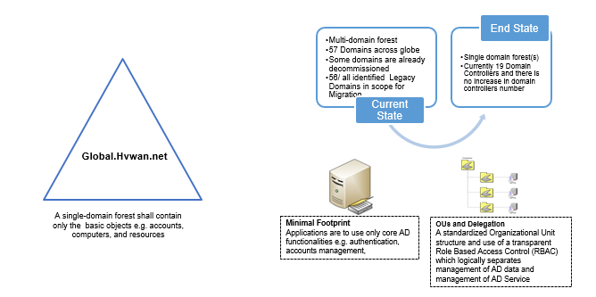

Figure 2 – Target Production Corporate Active Directory
HCL will migrate the Servers from the 57 legacy Active Directory domains which is identified for the AD consolidation. The List of domains for the consolidation is mentioned in the section Site Wise Legacy Domain List and Efforts of this document. In-Scope activities in the below document in a manner that will achieve the following objectives and results:
- All new built should be based on signed contract between HCL and Husqvarna, for AD related services and policy for infra services provided by HCL.
- The patching and vulnerability management on All new, uplifted or changed environment will happen on regular basis as defined in MSA for infra services support in BAU
- Global AD Standardization to be enabled basis identified gaps and clean-up agreed in detailed solution review
- Global AD standardization basis agreed SLA within HCL and Husqvarna for operational active directory services
- The Migration activities in the document only refers to the Servers and Domain Controllers which is member of the domains mentioned in the Domains and Efforts section.
- The common objective is to start the domain consolidation of 35 legacy domains in scope by Sep 2016
- This Migration will help in future to achieve the single forest Single domain Model for Husqvarna, however the domains in scope for migration is 57 Legacy domains.

Legacy Domain Migration Strategy
The HCL’s AD consolidation approach will ensure a seamlessly transformation of the 57 legacy domain member servers to the Global active directory domain. The Migration is not just focused on the technology, it also supports service management and business change activities that may be needed to make migration a success. The AD consolidation aims to help Husqvarna plan and execute a migration to the global domain, but with minimal disruption to IT services.

- The detailed assessment will be done in the current environment to identify the list of users, groups and computer objects in the domain and the comparison of the legacy vs global to identify the migrated or non-migrated users and groups.

- The list of active users in the legacy domains will be assessed in the initial phase of the project and involve Husqvarna to verify and remove the dependencies for users accessing the resources using the legacy user accounts.

- Server objects assessment will be done for each of the legacy domains to find the server active/in-active or retired status, Microsoft assessment planning tool kit will be used to identify the active servers and fetch the applications installed on each server. Also the customized scripts will be used to fetch the necessary reports.

- ADMT is already installed and migration team will leverage the same tool will be configured and soft match of the users and group will be done from all 35 legacy domains to the global domain to create the database in the migration tool which is needed for the server reACL.

- POC will be done and we will document the test cases and results, the list of servers will be identified from the pilot domains in consultation with Husqvarna.
- The server wise migration approach/task list will be prepared in co-ordination with Husqvarna for the migration of the servers from the legacy domain to Global domain.

The following phase’s shows the detailed migration phases and activities will be done by HCL for the domain consolidation.
Migration will be addressed as a transformation activity and are necessarily complex. The following approach shows the stages undertaken to perform an Active Directory migration including some of the major considerations and also initiatives that need to happen along the way. These stages will need to be followed for each Active Directory forest that is to be transitioned into the new GLOBAL Active Directory – either existing forests or additional forests that are part of a merger or acquisition.

Migration Approach
The below standard approach will be followed during the migration of legacy domain from the assessment to decommission of each domain.

Assessment and Planning Phase

- Identification of key stakeholders
- Current environment Assessment
- Customized scripts will be used to take the AD reports for the better comparisons
- Assessment of users, resources and Servers in each domain
- Soft match of users and groups – Already migrated
- Trust relations assessment and validation
- Assessment report for each domain
- Review with Husqvarna for approval
- BOM finalisation for Tools and migration infrastructure
- Identification of Pilot Domains
- Planning

Deploy and Test Phase

- Infrastructure reediness for Migration
- Tools deployment and configuration
- Test the tools functionality
- Test cases and UAT
- Performing the test cases and sharing the results with Husqvarna
- Sign of for the test

Pilot Phase

- Pilot domains (Fry.Lan and Flentdom.Local)
- Create appropriate Changes for the Pilot
- Approval from Husqvarna for the down times
- Pilot
- Pilot results
- Sign of the pilot

Production Migration Phase

- Validating the pilot results and issue fixing
- Scheduling the productions migrations
- Piloting for each Domain
- Pilot results
- Acceptance
- Required changes in place
- Production migration
- Sign off for each domain

Post migration support and Decommission

- Setup monitoring of old domains to ensure complete migration (Change Auditor)
- Monitor domain when basic migration is done
- Setup and operate activity reporting per domain
- Setup and operate Domain Controller status reporting
- Initiate and track final retirement of Domains
- Shut down the domain controller
- Decommission

The below table describes the complete key deliverables and completion criteria for each of the phases.

Ref. No. | Milestone | Description/Comments | Husqvarna Dependencies | Completion Criteria
1 | Pre-Assessment of Pilot domains | Do the Pre-assessments for the identified pilot domains | None | Pre-Assessment report for the 2 pilot domains. Users with the last accessed days in legacy domains, Groups, Client OS Computers with the last accessed days, Server objects status with active or inactive status along with the applications installed on the servers.
2 | Current Environment Assessment | Do the assessments for all the 35 domains for the Users, Groups and Computer objects | Compare and validate the missing users and groups legacy vs global AD. | Assessment report for the 33 legacy domains. Users with the last accessed days in legacy domains, Groups, Client OS Computers with the last accessed days, Server objects status with active or inactive status along with the applications installed on the servers. Missing users and groups vs global domain.
2 | Current Environment Assessment | Compare all the users, group objects in Legacy Vs Global domain to verify the migrated objects.
3 | Infrastructure Readiness | Install and configure the ADMT migration tool to do the POC. |  | Share the report of Active Users in Legacy domain, Users or groups not migrated to global domain and the active client OS computer objects in the legacy domains.
4 | User Identity and Provisioning | Husqvarna to migrate the missing users, groups and instruct the active legacy users to login with global domain credentials to eliminate the dependency of the legacy domain user accounts. Also the plan and migrate the active client OS computers from the legacy domain. | Sign-off from Husqvarna to ensure no production users are using the legacy domains. Also the plan or sign-off for the active client OS computers. | Sign-Off from Husqvarna on the no dependency on user identity in the legacy domains apart from the active service accounts used in the server services.
5 | Source Preparation | Prepare the application remediation plan with the help of Husqvarna and also prepare a task list for the identified list of servers for the POC. | Husqvarna has to confirm few servers for the pilot migration and ensure the application remediation. | Acceptance of List of Servers for the POC, application remediation plan for the identified servers and the task list for the migration.
6 | Test Cases and Development | Do the POC using the identified servers from the pilot domains and document the test cases and results. | Review the test cases document and POC results and provide the sign-off. | POC documents and test case results and POC sign-off.
7 | Prepare Design/Planning Document | Prepare the detailed design document and sign-off. | Review and sign-off the design/planning document. | Acceptance by Husqvarna for the design/planning document.
8 | Communication Schedule | Husqvarna has to prepare the communication plan and schedules to the end users regarding the migration. | Create an communication plan and communication schedule | Detailed Communication plans and schedules.
9 | Finalize the Application Inventory | Based on the Assessment shared in section A1, Husqvarna has to review and finalize the list of applications and prepare the application remediation plan to migrate it to the Global AD. | Finalize the list of application servers and remediation plans. | Acceptance for the list of application servers and remediation plans to migrate it to target domain.
10 | Create/Verify Trust | Create/Verify the domain/forest trust between the Legacy and Global domain. | Review and approval to create the Trusts. | Infrastructure readiness for the Forest to Forest communications.
11 | Compare the Objects | Compare the objects in the legacy domains and soft match the users and groups for the 35 legacy domains. | None | Building the database in migration tool and migration readiness to reACL the servers using the tool during the server migration.
12 | Pilot and Pre-Stage Migration | Identify the list of servers for the pilot migration and create a task list along with the application remediation plan in co-ordination with Husqvarna application SPOC. | Provide the application remediation tasks and the sequence of the application tasks in overall migration plan for each server. | Pilot migration and findings. Decide to Go/No Go for velocity migration.
13 | Velocity Migration | Create a detailed dependencies and application remediation plan each server and migrate 590 servers from the legacy domains as per the initial assessment report and migrate it to the global AD. | Provide the application remediation tasks and the sequence of the application tasks in overall migration plan for each server. | Production Migration from the Legacy domain to Global AD.
14 | Post Migration Support | Post migration support will be provided for each migrated servers for the next 2 weeks after migration and the remediation to fix the issues for the infrastructure related issues. Also for the application related issues, we will coordinate with the application team to troubleshoot the issue. | Application level support and remediation has to be done by the application owner. | Successful Migration and Handover.

Migration Tool
Active Directory Migration tool kit (ADMT) is the migration tool selected for this project considering huge value saving in money factor, there are few limitations by using this tool and the mitigation steps has been provided for the limitation.

Centralized Approach
- One ADMT Project DB for all Source AD and Target AD domain pair.
- One ADMT Server connect to one SQL DB Server.
- Input file will be used to reACL the servers.

Benefits

- ADMT is a free tool which is more benefit to do the server migration without any cost. Single point of reference for all the migrations that occurs within organization.
- HCL Recommends the ADMT as migration tool considering the other objects (Users, Groups and Workstations) are already migrated and providing the cost benefit solution. There are some limitations which can be jointly worked by HCL and Husqvarna to save valuable money.
Assumptions
- HCL assumes that the Users, Groups and Workstations are migrated from all the domains and if any users are still using the legacy domain credentials it is responsibility of Husqvarna to migrate the users to Global domain.
- The File Servers will be migrated AS IS migration and there will not be any change in the folder restructuring during this migration.
Limitations
- Undo migration is not feasible in ADMT.
- SIDHistory cleanup is not possible by using ADMT.
- OU Migration is not feasible using ADMT.
- Delegation of Task is not feasible using the ADMT and it should be run using a single account.
- IntraOrg Migration Copy Account is not feasible using ADMT.
- Distributed Installation is not possible in ADMT.
- Microsoft does not support moving an already installed and configured Windows Server 2008 or Windows Server 2008 R2 failover cluster from one domain to another.
- SQL security translation is feasible after running scripts and mitigation.
- IIS security translation is feasible after running scripts and mitigation.
- ADMT can't translate permissions for shared folders on network attached storage (NAS) appliances.
- Agentless Updates, Exchange content and permissions is not feasible using ADMT
Mitigation Steps
Ref. No | Risk Category | Anticipated Risks | Impact Description | Ownership | Mitigation Plan
1 | Re-ACL SQL DB | Non-availability of the application owner to perform the UAT | Project delay. | Application Team / DB Team / Husqvarna | There are some Pre-requisites has to be manually performed in local system settings and Target AD. Associated Service account has to be migrated and SQL DB administrator should apply the permission to change the domain permissions with in SQL to re-ACL the permissions in SQL.
2 | Re-ACL IIS Servers | Non-availability of the application owner to perform the UAT | Project delay. | Application Team / MW Team / Husqvarna | This needs the complete validation by the application owner to check the feasibility and re-ACL the IIS application level.
3 | Re-ACL Sharepoint Servers | Non-availability of the application owner to perform the UAT | Project delay. | Application Team / Husqvarna | Share point User permission has to be changed using stsadm -o migrateuser and customized scripts needs to be developed for the Group Permission changes within the Share Point ACL's. This needs the complete validation by the application owner to check the feasibility and re-ACL the Share point in application level.
4 | Systems Management Server /System Center Configuration Manager | Non-availability of the application owner to perform the UAT | Project delay. | Application Team / Husqvarna | If available we need to involve SCCM application support group. This needs the complete validation by the application owner to check the feasibility and re-ACL the SMS/SCCM application level.
5 | NAS/SAN devices | Input file creation with the reference of old SID and new SID or Samaccount name to re-ACL the NAS or SAN devices | Project delay. | DC Transformation Team / Husqvarna | Not Applicable for Husqvarna. However, customized Scripts can be developed to re-ACL the permissions.

List of Domains and Status
The list of legacy domains from the Husqvarna multi sites and the current status.

Domain Name | Access Status | Assessment | Migration | Complete Decommission | Remarks
jfs.com | Yes | Yes | Yes | Yes | Decommissioned by HCL AD TnT
fi.hvwan.net | Yes | Yes | No | No | Assessment completed long back
gardena.com | Yes | Yes | No | No | Assessment report shared with identified site SPOC
gde.gardena.com | Yes | Yes | No | No | Assessment report shared with identified site SPOC
no.hvwan.net | Yes | Yes | No | No | Assessment completed long back
DIMAS-AD.LOCAL | Yes | Yes | No | No | Assessment completed long back
dw.ext.hvwan.net | Yes | Yes | No | No | Assessment completed long back
timtestad.hvwan.net | Yes | Yes | NA | NA | Test Domain, will not be migrated
husqvarna.com.br | Yes | Yes | No | No | Assessment completed long back
columbia1.cp.electrolux-na.com | Yes | Yes | No | No | Assessment completed long back
Beatrice.Electrolux-na.com | Yes | Yes | No | No | Assessment completed long back
SE2.hvwan.net | Yes | Yes | No | No | Assessment report shared with Husqvarna
SE.hvwan.net | Yes | Yes | No | No | Assessment report shared with Husqvarna
cp.electrolux-na.com | Yes | Yes | No | No | Assessment completed long back
hcc.ca.hvwan.net | Yes | Yes | No | No | Assessment completed long back
hcop.us.hvwan.net | Yes | Yes | No | No | Assessment completed long back
huskyclt.com | Yes | Yes | No | No | Assessment completed long back
advplast.cz | Yes | Yes | No | No | Assessment completed long back
dk.hvwan.net | Yes | Yes | No | No | Assessment completed long back
ar.husqvarna.com.local | Yes | Yes | No | No | Assessment completed long back
husqau.lan | Yes | Yes | Yes | No | Migration phase and in discussion with Site SPOC remaining servers
diamant-boart.com.cn | Yes | Yes | Yes | Yes | Decommissioned by HCL AD TnT
ee.hvwan.net | Yes | Yes | No | No | Assessment completed long back
uk.hvwan.net | Yes | Yes | No | No | Assessment completed long back
lv.hvwan.net | Yes | Yes | No | No | Assessment completed long back
lt.hvwan.net | Yes | Yes | No | No | Assessment completed long back
HUSQWAW.local | Yes | Yes | No | No | Assessment completed long back
koluszki.polska | Yes | Yes | No | No | Assessment completed long back
Husqvarna.local | Yes | No | No | No | Assessment yet to be taken
husvarna.localhost | Not Found | No | No | No | Not Available
hsqtestad.hvwan.net | Yes | No | No | No | Assessment yet to be taken
hu.hvwan.net | Yes | No | No | No | Not Available
sl.tpc.local | Yes | No | No | No | Assessment yet to be taken
HOPI.LOCAL | Yes | No | No | No | Assessment yet to be taken
CP.COM | Yes | Yes | Yes | Yes | Decommissioned by HCL AD TnT
diamant-boart.com | Yes | Yes | Yes | No | Migration phase and in discussion with Site SPOC remaining servers
husqvarna.jp | Yes | No | No | No | Assessment yet to be taken
jp.hvwan.net | Yes | Yes | Yes | No | Migration phase and in discussion with Site SPOC remaining servers
Pc.zenoah.kmtg.net | Yes | Yes | No | No | Migration phase and in discussion with Site SPOC for active clients and users
nz.electrolux.corp | Yes | Yes | Yes | No | Migration phase and in discussion with Site SPOC remaining servers
NT1_NORWAY | Yes | No | No | No | Assessment yet to be taken
husqvarna_nt.polska | Decom | No | No | No | Already Decommissioned
fk.hvwan.net | No | No | No | No | No Access to HCL
fktest.hvwan.net | No | No | No | No | No Access to HCL
Ga.ext.se.hvwan.net | Yes | Yes | No | No | Assessment completed long back
Hqv.se | Decom | No | No | No | Already Decommissioned
NT1_STOCKHOLM | Decom | No | No | No | Already Decommissioned
gde.ext.hvwan.net | Not Found | No | No | No | Not Available
engineering.local | Decom | No | No | No | Already Decommissioned
cz.zenoah.kmtg.ne | Decom | No | No | No | Already Decommissioned
husqvarna.sk | Decom | No | No | No | Already Decommissioned
DIMAS.LOCAL | Decom | No | No | No | Already Decommissioned
coe.husqvarna | Decom | No | No | No | Already Decommissioned
husqvarna.com | Decom | No | No | No | Already Decommissioned
husqvarna.com.pe | Decom | No | No | No | Already Decommissioned
IT.HVWAN.NET | Decom | No | No | No | Already Decommissioned
Electrolux.bg | Decom | Yes | No | No | Already Decommissioned
tpc.local | Decom | No | No | No | Already Decommissioned
Fry.Lan | Yes | Yes | Yes | Yes | Decommissioned by HCL AD TnT
Flentdom.local | Yes | Yes | Yes | No | Pilot Domain remaining 3 servers needs to be migrated, on-hold until June

Distributed File System
Background
Distributed File System (DFS) is a set of client and server services that allow an organization using Microsoft Windows servers to organize many distributed SMB file shares into a distributed file system. The Distributed File System Replication (DFSR) service is a new multi-master replication engine that is used to keep folders synchronized on multiple servers. Replicating data to multiple servers increases data availability and gives users in remote sites fast, reliable access to files.
A DFS namespace is a virtual view of shared folders in an organization. Using the DFS tools, an administrator selects which shared folders to present in the namespace, designs the hierarchy in which those folders appear, and determines the names that the shared folders show in the namespace.

HUSQVARNA Experience with DFS
HUSQVARNA makes extensive use of DFS within some of the legacy Active Directory environment, for a range of reasons:
- Virtual view of the DFS namespace for the shared folders
- Standalone or Root DFS roots to manage the namespace in the environment
- To eliminate the direct UNC path of each share, however this is applicable for few domains where it is implemented.

Strategy for use of DFS within the HUSQVARNA GLOBAL environment

- Husqvarna global strategy for DFS is to use the domain DFS share.
- The DFS naming convention stands in the form of DFS Root, Division, Country, Site, Department and department name.
- The below DFS sample architecture explains the DFS naming standard in the Husqvarna global domain.
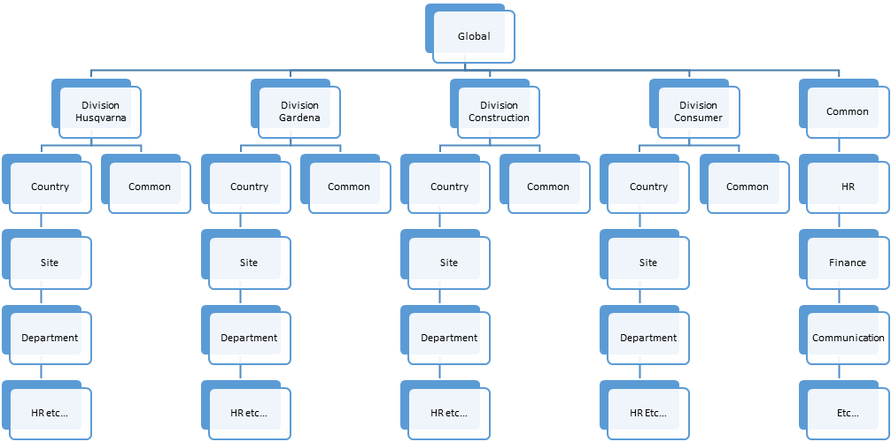

Global Domain Stabilization Design

Future Road Map
- Reduce the risk in the infrastructure
- AD topology for the better replication model.
- OU Level delegation for the existing support groups with the limited access to manage the resources.
- Reduction in number of GPO’s and would be deleted the not required GPO’s which is not in use.
- Sensitive group members reduced according to the feasibility.
- Process to take action on clean-up the user inactive/disabled accounts.

What is being changed
- Addition of Organization Units to support migrated objects
- Site and services (Replication topology) – INVID be central site
- FSMO role placement to INVID DC
- Clean-up of unnecessary GPO’s
- Implement the best practices according to the assessment

Forest and Domain Trusts
A trust is a mechanism within Active Directory that is used to establish a security connection between domains, typically to allowing users in one domain to access resources in another. Trusts can be implemented at the domain level or at the forest level and can be configured either as one-directional or bi-directional. When a forest trust is created (forest trusts are always bidirectional), all of the domains in both of the forests transitively trust each other.
Trusts can be classified as either internal or external. An internal trust is a trust between domains in the same forest, whereas an external trust is between two forests, or two domains in different forests.

Trust Strategy after Global Consolidation
All the existing trust with Global domain will be removed before decommissioning the Legacy domain.

Domain Controllers
Domain controllers are servers that provide the physical presence of Active Directory. Domain controllers provide a variety of functions, including:
- Authentication of users during the logon process
- Authorisation of user access to resources
- Provision of Group Policy to users and computers. This is initially processed at startup in the case of computers, or at logon in the case of users. Following the initial processing, group policy is refreshed periodically – approximately every 60 minutes.
- Serving of LDAP data to directory integrated applications. For example, users of Microsoft Exchange connect to Active Directory in the background to determine email addresses and membership of distribution lists.
Given that domain controllers are used for a range of purposes, good choice of placement is essential to ensuring an acceptable user experience or good application performance. However, there are obvious benefits to cost and support by having fewer domain controllers.

Domain Controller Platform Strategy
The domain controller role will deployed only to dedicated single-purpose OS instances. It will not be deployed on multi-purpose servers such as file and print servers or application servers. This will provide an OS platform dedicated to providing performance and role separation so as to facilitate upgrading the domain controller role without having to have regard for co-located applications.
All domain controllers will run the Windows 2012 R2 operating system. Prior operating systems will not be used to run the domain controller role and will not be supported.
All domain controllers (except those hosting FSMO roles) will be deployed on virtual infrastructure as standard practice and physical hardware via exception. The use of some physical infrastructure will ensure Active Directory availability in the event of catastrophic virtual infrastructure failure. The use of virtual infrastructure lowers costs, improves utilisation, and allows more rapid scaling and expansion.

Domain Controller Placement Strategy
Determining an appropriate placement strategy for domain controllers is an important part of any Active Directory deployment. The high level influences on the strategy are as follows:
- The risk and impact associated with domain services being unavailable, either through a domain controller being down, or a remote domain controller being inaccessible due to a WAN failure;
- The performance expectations and commitments of the platform. A high expectation of performance requires a larger number of domain controllers, and domain controllers located closer to users and resources.
From a sizing perspective, the Windows Server 2012 R2 Active Directory Infrastructure Planning and Design Guide, indicates (in step B2) that two domain controllers equipped with four CPU cores can service up to 10,000 client systems. Further, in general one additional domain controller may be required for every additional 5,000 users. While this is a reasonable basis for starting it does not account for anything specific to HUSQVARNA. It is necessary to baseline and monitor the performance of the environment and scale accordingly.
A one-size-fits-all approach is generally impractical – particularly for large, diverse organisations such as HUSQVARNA. Different sites will have different requirements based on the nature of work being performed at the site. Using a count of users on site is a common, but crude measure. A location performing non-time critical back end processing, with no customer contact, will likely tolerate an outage for some time, even if a large number of staff are employed at the site. By contrast, a remote office containing brokers or traders will likely require a highly available, redundant service, even for a small number of staff.
Also influencing the HUSQVARNA placement strategy is:
- The strategy and trend towards centralisation of services within the data centre;
- The improvements to performance and availability of wide-area network links;
- The advent of virtual desktop infrastructure (VDI), which results in the centralisation of all services to the data centre (even the desktop);
- The previous experience of HUSQVARNA, where a large number of domain controllers contributed to a significant reduction in agility within the legacy environment
- The domain controller role will deployed only to dedicated single-purpose OS instances
- It will not be deployed on multi-purpose servers such as file and print servers or application servers
- All domain controllers will run the Windows 20012 R2 operating system / Windows 2016
- All domain controllers (except those hosting FSMO roles) will be deployed on virtual infrastructure as standard practice and physical hardware via exception.

Global Catalogues
A global catalogue is a domain controller that stores a copy of all Active Directory objects in the forest. The global catalogue stores a full copy of all objects in the directory for its host domain and a partial copy of all objects for all other domains in the forest.
Within the GLOBAL Active Directory, all domain controllers, including RODCs, will be deployed as global catalogues, as:
- In a single domain forest, there is no overhead in replicating the global catalogue between domain controllers. On a domain controller in a single domain forest, the partial attribute set (PAS) will be generated from the local domain partition.
- All hub sites must have global catalogue to support authentication.
- Tail sites with a need to be autonomous through a WAN link outage require the global catalogue function for authentication.
- Tail sites with more than 100 users have a domain controller for authentication; this domain controller must also be a global catalogue to support authentication.
- Global catalogues are required to support Exchange Server 2010. Exchange communicates exclusively with the global catalogue.
Within the HUSQVARNA GLOBAL environment there are fewer considerations for management of the global catalogue as was the case with the legacy Active Directory. The key points are as follows:
Consideration | Description | Comment
Full Sync | Forests running in Windows 2000 forest functional mode have an issue whereby anytime that an attribute is added to the global catalogue’s partial attribute set (PAS), a full re-sync of all content in the global catalogue is performed. For large forests this can cause considerable additional load on the network.  Due to improvements in Windows 2003 forest functional level and above, the addition of an attribute to the global catalogue does not cause a full re-sync. | Not applicable to this solution. The GLOBAL environment operates at the Windows 2012 R2 forest functional level. This is an issue in the CORP environment which operates at the Windows 2000 forest functional level.
NTDS Database Size | In multi-domain forests, the addition of attributes to the global catalogue will cause the size of the NTDS database to expand, due to the extra storage required. | Not applicable to this solution. The GLOBAL environment is a single domain forest and every domain controller already contains a complete copy of the database.  This is applicable to CORP, which is a multi-domain forest.
Additional replication traffic | In multi-domain forests, the addition of attributes to the global catalogue will cause additional replication traffic. | Not applicable to this solution. The GLOBAL environment is a single domain forest and every domain controller already contains a complete copy of the database.  This is applicable to CORP, which is a multi-domain forest.
Data Security | All content in the global catalogue is able to be read by any authenticated user - ACLs within Active Directory are not applied to global catalogue data. | Applicable to HUSQVARNA, both CORP and GLOBAL. Attributes must not be added to the global catalogue unless there are no data security requirements beyond a user being authenticated.
Table 5 - Global Catalogue Management Considerations

FSMO Placement
Active Directory defines five FSMO roles. These FSMO roles are hosted on domain controllers. The FSMO role scope and configuration requirements are as follows

FSMO Role | Scope | Configuration Requirements
Schema Master | One per forest | The Schema Master and Domain Naming Master can be on the same domain controller and this should be a global catalogue
Domain Naming Master | One per forest
RID Master | One per domain | PDC Emulator and RID Master should be on the same domain controller and this should be a global catalogue
PDC Emulator | One per domain
Infrastructure Master | One per domain (although technically it is possible to configure one per naming context) | Infrastructure Master should be on a domain controller that is not a global catalogue (unless there is only one domain in the forest, or all domain controllers host the global catalogue).
- Within the GLOBAL environment, domain scoped FSMO roles will be hosted on one server, and forest scoped FSMO roles on another. This means that the RID Master, PDC Emulator and Infrastructure Master for GLOBAL will all be hosted on the same domain controller.
- Special consideration is needed on the Infrastructure Master FSMO role, whose job it is to update inter-domain cross-references when objects are moved, renamed, or deleted. It cannot do this if it is also hosted on a global catalogue server. However, the Infrastructure Master can be on a domain controller hosting the global catalogue in any of the following three circumstances:
- When there is only one domain in the forest. In this case there are no inter-domain cross references to update, and therefore no work for the Infrastructure Master to perform.
- When every domain controller in the domain also hosts the global catalogue. In this case every domain controller has a copy of every object in the forest. This copy can be referred to directly, without needing to refer to the cross references maintained by the Infrastructure Master.
- In Windows 2008 R2 domains with the Active Directory Recycle Bin enabled, every domain controller is responsible for updating cross domain references when objects are moved, renamed, or deleted. In this case, there are no tasks associated with the infrastructure master, and it is not important which domain controller owns the infrastructure master role.
Current FSMO Placement:
  - All five roles placed in SW00001.Global.Hvwan.net Domain Controller and it is in SEHSQ site.
Future State:
  - FSMO Roles will be placed in INVID DC and NTP will be reconfigured for PDC and other DC’s to pointed to domain hierarchy
  - Schema Master – SW01701.global.hvwan.net
  - Domain naming Master- SW01701.global.hvwan.net
  - PDC –SW01625.global.hvwan.net (Physical Server)
  - RID Pool Manager – SW01625.global.hvwan.net (Physical Server)
  - Infrastructure Master – SW01625.global.hvwan.net ((Physical Server)

Active Directory Sites and Services
In an Active Directory infrastructure setup, the Domain represents the logical topology while Sites and Subnets represent the physical topology. A site can simply be defined as a physical location or network. It can be separate building, separate city or even in separate country.
Site Topology and Replication
- Active Directory sites define how replication between domain controllers functions within a given forest. The Active Directory sites architecture includes IP subnets, site links and configuration decisions for frequency, schedule and cost model for topology generation.
- The Active Directory site topology is a logical representation of the underlying physical network; this topology is how Active Directory is told about the actual network it will run on. The site topology includes planning for domain controller placement to provide adequate authentication services while maximising network efficiency. Active Directory clients utilise DNS and the site topology to locate ‘close’ domain controllers and other services which leverage Active Directory sites (such as printing, DFS, etc.). The site topology is a critical aspect for initial deployment and on-going Active Directory operations. A well architected topology enables efficient Active Directory usage.
- Windows Server 2012/R2 updates the Active Directory site technology to include native support for IPv6 and a new client and server extension known as ‘next closest site’. The ‘next closest site’ feature enhances the domain controller location process by enabling the client to use the Active Directory site topology and cost model to look for an optimised alternate domain controller rather than randomly querying DNS and possibly locating a domain controller in a remote location (when a domain controller is not found in the client’s existing site). ‘Next closest site’ is only available for Windows Server 2012/R2, Windows Vista and Windows 7; this feature is off by default and is enabled via a Group Policy setting.
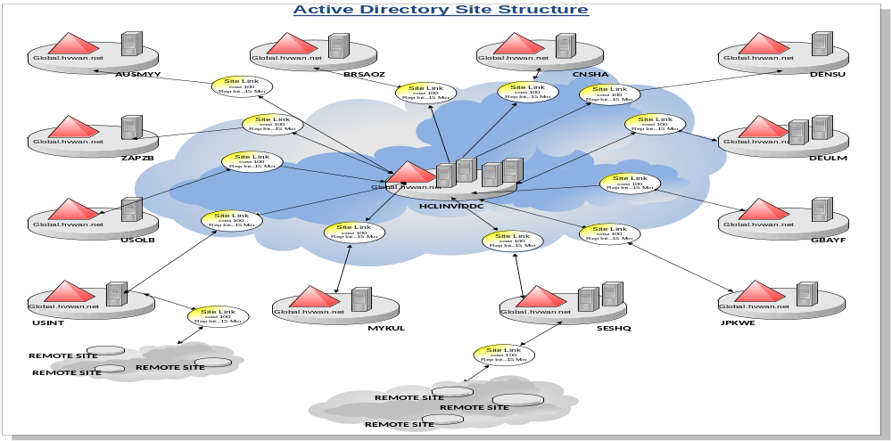

Site Links
- Site links will be created in the GLOBAL.HUSQVARNA.NET forest/domain using the following criteria:
- A site link will be created between the tail site and its logical upstream hub site. In countries with redundant data centres the upstream site is the Active Directory site that spans the two data centres. In countries with a single country headquarters data centre the upstream site is the data centre. These site links will be created with a cost of 100.
- For tail sites without a domain controller, it would be possible to create a single site link that contains all of the tail sites. This would achieve the aim of directing authentication traffic to the domain controllers in the upstream site.
- However, it would not ensure that DFS referrals were always directed to the data centre site. DFS replicas may exist in the tail site even when there is no domain controller on site, and it would be inappropriate for the DFS referral to be directed to another tail site when the local DFS replica was unavailable.
- The links between the Data Centre sites and the LDAP farm sites are required for replication, but are set to a high cost to ensure that non-application requests are not directed to the LDAP farm domain controllers.
- Site links will be created between the data centre core sites, and the data centre user authentication sites, with a cost of 100.

Site
- A site will be created in the GLOBAL.HUSQVARNA.NET environment using the following criteria:
- For countries with redundant Datacenter an Active Directory site will be created which spans both data centres.
- It is assumed that the link speed from tail sites to both data centres is the same, and that the link speed between the data centres is approaching LAN speed. By creating a single site to span both data centres the replication and authentication traffic can be evenly distributed between the data centres, failover is seamless, and the topology is simplified.
- For countries with a single data centre, an Active Directory site will be created for the ‘hub’ site.
- Each of these sites will have a writeable domain controller. A site needs to be created to control inter-site replication between countries, control inter-site replication from the hub to tail sites.
- All tail sites without a domain controller will have an Active Directory site created for it and pointed to nearest Domain Controller placed AD site and to control authentication traffic.
- A site needs to be created to direct DFS namespace resolution to the local replica, and is also used for directory search of nearby objects (such as printers). Authentication traffic will be directed to the upstream hub site as a result of auto-site-coverage. That is, every office/site will have a corresponding Active Directory site.

Subnets
- In the GLOBAL.HUSQVARNA.NET forest/domain, the subnet to site mapping will follow the approach of:
- In non-data centre sites, all subnets in the site will be part of the Active Directory site for that building.
- In data centre sites, subnets servicing client user authentication will be part of a separate data-centre-user site.
- In data centre sites a number of subnets will be part of the cross-data centre Active Directory site. That is, for the sites that span across two data centres there will be subnets assigned to those sites. This will create the ability to load balance authentication requests between the data centres.
- Load balancing in this case will be provided by a native feature in Active Directory. This does not require the use of a hardware load balancing solution.

DNS Design
DNS is used throughout HUSQVARNA for standards based hostname registration and resolution. The existing Legacy DNS namespace as a delegated DNS zone from the internal root DNS server. Similarly, the corporate forest (GLOBAL.HVWAN.NET) will host the *.GLOBAL.HVWAN.NET DNS namespace as a delegated DNS zone from the same internal root DNS server. This will provide a fully contiguous DNS namespace and ensures that DNS clients can resolve the FQDN of hosts from both the existing and new corporate forests.

DNS Servers
It is generally good practice to deploy a DNS server to every site. The rationale behind this recommendation is that in sites with multiple subnets and/or servers, DNS is necessary for clients to locate resources. DNS is also necessary for clients to locate off-site resources, and critically, to be able to log on to Active Directory. As DNS is used by clients to logon to Active Directory, it is also generally the case that all domain controllers are also configured as DNS servers. This provides a simplified configuration, as all domain controllers are configured the same, and also ensures that the DNS service, on which Active Directory depends, is as widely available as Active Directory itself.
From a DNS server perspective, the key design points are as follows:
- All domain controllers will be configured as DNS servers.
- All Read-only domain controllers will be configured as DNS servers.
- DNS zone replication will be configured to use ‘All DNS servers in the Active Directory domain’. This isolates DNS records from other LDAP records in Active Directory and allows replication to be more closely monitored.
- Legacy domain zones imported to the standalone DNS servers which is placed in the 4 locations and the conditional forwarders will be created in Global DNS servers.

DNS Client Configuration
DNS client configuration will differ depending on the site where the client is located and what services are on offer.
Note:
It is MANDATORY that every DNS client in the global domain be configured with three DNS servers - a primary, secondary, and tertiary. The tertiary DNS server MUST always be a DNS server from one of the hub data centres. Every DNS client, no matter where it is based, MUST have this configuration. This configuration is necessary to ensure the rapid recovery of services in a disaster situation. Clients not following or implementing this configuration are at risk that service continuity RTOs will not be met in a disaster situation.
Windows-based DHCP services are used throughout the HUSQVARNA for IP address allocation to Windows clients and more recently servers. This Solution Architecture will detail support for DHCP services provided on a Windows Server 2012 R2 platform to meet HUSQVARNA requirements. This will require a staged migration of DHCP scope information from the legacy DHCP servers.

DHCP Servers
HUSQVARNA currently operates two DHCP member servers in HCL Invid Datacentre to supply IP addresses for all subnets across the globe. These two DHCP servers in Invid and the routers on each site are configured with ‘DHCP helpers’ to forward DHCP requests to these two DHCP servers.
Internationally, a pair of DHCP servers is deployed in each region, and use a similar configuration to the Invid DHCP servers. This allows administration of the DHCP servers to be delegated to the in-country IT support team.
In the past, it was common practice to implement DHCP redundancy via a split scope arrangement. With this configuration the primary/secondary DHCP servers would be configured to provide addresses from different address ranges within the same subnet, generally on a 50/50 or 80/20 basis. This is a fairly crude mechanism that generally results in imbalanced scope utilisation across the DHCP servers. A new feature in Windows 2012 R2 provides improvements via the ‘Delay in DHCP Offer’ configuration.
HUSQVARNA will leverage the Delay in DHCP offer configuration. The three secondary servers will be configured with identical scopes, address ranges, and scope options as the primary, but will also have the Delay in DHCP Offer option configured. This will cause a response delay in DHCP offers from the secondary, ensuring that the primary has first preference. This is not a split scope, as the primary and secondary servers both have identical scopes defined (i.e. 100/100).
Migration approach for the legacy domain scopes will be migrated by export and import in the existing DHCP servers in the Global domains. If any many number of scopes running on the server only with DHCP role will be migrated to global domain according to the feasibility and in-agreement with Site Spoc.

DHCP Clients
To provide fault tolerance, routers will be configured with ‘DHCP helpers’ to forward DHCP requests to two DHCP servers. DHCP Options and Lease Configuration

DHCP Options
DHCP can be used to supply a wide variety of configuration settings to clients. The following options will be delivered to all clients within the GLOBAL environment via DHCP:
Option No | Description | Purpose
003 | Router | Defines the default gateway for the client.
015 | DNS Domain Name | Sets the primary DNS name of the client.
135 | Domain Suffix Search Order | Defines the list of domains used by the client to resolve short host names.
006 | DNS Servers | Defines the DNS servers used by the client. Each client will be configured with a primary, secondary, and tertiary DNS server.
066 | Boot Server Host Name | Defines the PXE server used by client needing to boot from the network for OS deployment
Table 6 - DHCP Options
Note:
Domain suffix search order is also capable of being set via group policy.

DHCP Lease Duration
Lease durations within the GLOBAL environment will be configured as follows:
Client Type | Recommended Lease Duration | Justification
Wired | 8 Days | Provides a long period of time (4 days) before a DHCP issue becomes service impacting. This setting matches the legacy configuration and thereby eliminates the risk of scope exhaustion as a result of a DHCP migration.
Short term system build networks | 2 hours | Networks used on a short term basis for system builds need to be rapidly recycled.
Wireless | 2 hours | Allows wireless IP address pool to be recycled regularly.
VPN | 2 hours | Allows VPN IP address pool to be recycled regularly.
Table 7 - DHCP Lease Duration

Sensitive Groups
Sensitive Groups has to be maintained with more carefully with the process to maintain the list of members to avoid the risk in the environment.
- The process comes with the below list of Sensitive Groups
  - Enterprise Admins
  - Schema Admins
  - Domain Admins
  - Administrators
  - Server Operators
  - Backup Operators
- Need to include the sensitive group members report in the Monthly Reports.
- Get the approval with Justification from Richard Jung to add any new users in the sensitive groups.
- Review the 45 days inactive users and get confirmation to remove the user from the sensitive groups.
- Review the list of accounts with Stakeholders every 3 months and ensure only required members are in the sensitive groups.
AD Sensitive Groups – Management Options
  - Limit the number of Domain Admins and review the current DA members with Husqvarna
  - All new DA requests need approval from Husqvarna (Richard / Hakan)
  - Creating a Admin Group and follow the Approval process for Sensitive Groups for temp access
  - Create Empty Groups with Sensitive Group names
  - Providing the group management to limited Husqvarna Group and HCL Group
  - Whenever the Admin access is required go through the approval process through email approval
  - Track the approvals by recording at central locations
  - PIM TOOL
  - Current logging will not provide the real time alerting, granular auditing reports and trend analysis. Since it was agreed with Richard with BAU team on the current solution no further action is required on this
  - Note: Waiting for details from IAM Team
New PAM Feature in 2016 Active Directory
The new feature is available in 2016 Active Directory, attached here with the example view and it is possible after upgrade the DC’s with 2016 OS.
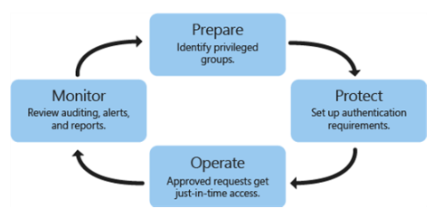

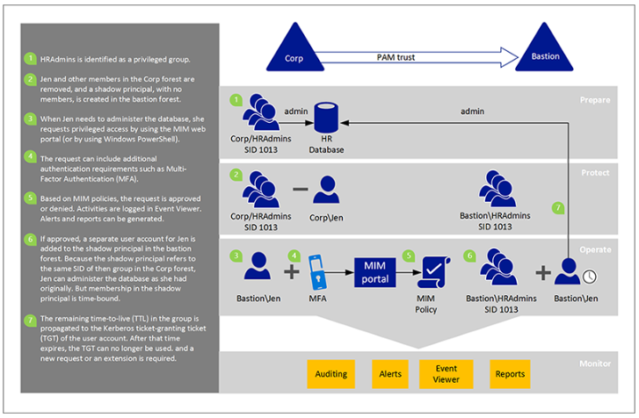

Organisational Unit Structure
This section contains the proposed OU structure for the GLOBAL Active Directory environment within HUSQVARNA. The delegation model is also discussed in this section, and an approach of central administration vs. delegated or in-country administration.
Where central administration is specified, this refers to central accountability for service operation, not necessarily operations from a central location. Members of a team responsible for central administration of a service may be split between multiple locations.

Background
Active Directory allows the creation of a logical hierarchical structure within a domain to facilitate delegation of administration, and for the collection of common resources for applying group policies. Organisational Units (‘OUs’) are the building blocks used to create this hierarchy. OUs are container objects that can contain users, computers, groups, child OUs and other Active Directory objects.
Granular permissions are applied to OUs to allow specific groups of administrators to perform administrative tasks – for example, helpdesk staff may be assigned permissions to reset passwords. If this is applied to a country-level OU, then the helpdesk staff would be able to reset passwords only in that country.
OUs are the smallest scope to which inheritable Active Directory permissions can be applied. Group Policies can be applied to all objects within an OU and can be filtered further based on group membership and WMI. This means that the primary consideration for the OU structure is for administrative delegation; group policy is a secondary influencing factor in any design.

Industry Best Practices for OU Design
The ideal OU design is one which meets the administrative delegation requirements of the organization whilst being as simple and free from ongoing change as possible. The following is considered industry best practice for OU design:
Driver | Key Points
Base top-level OUs on something that is unlikely to change | Use the largest administration boundary within the domain, such as a site or country.  Generally, it is not good practice to model the organisation’s organisational structure in the OU structure as organisational structures change over time, and may not correlate with Active Directory administrative delegation requirements.
Have a relatively static OU structure | A relatively static OU structure is a characteristic of a well-designed OU structure, as a ‘natural/obvious’ OU exists for every object in the directory. It also means that the organisation can grow and expand without changes to the OU structure.
Script the creation of OUs | Using VBScript/ADSI or similar. This ensures a consistent/correct OU structure is created (including OU descriptions). This also ensures that the OU structure can be reproduced or duplicated in a non-production environment.
Script the delegation of administration | Using DSACLS, Quest ActiveRoles, or similar. This ensures a consistent/correct delegation of administration model is implemented, and can be updated easily as requirements change. This also ensures that the delegation of administration model can be reproduced or duplicated in a non-production environment.
Have a consistent sub-OU structure under each top-level OU | For example, each sub-OU structure under the top-level OU should be the same. This may make scripting, searching, navigation and traversal of the OU structure easier, and provides a familiar, uniform structure for administrators.
Do not mix object types in an OU | A contacts OU should only contain Exchange contacts. Delegation of administration should prevent the wrong object types from being created/moved to the wrong OUs.
Do not mix the status of the same object type in an OU | e.g. a User Accounts OU should only contain enabled user accounts. Disabled user accounts (either temporary or permanent) should be moved to an appropriate OU.
Minimise the depth of the OU structure | A deep OU structure may be the result of too greater vertical categorisation resulting in many OUs with few objects. A depth of greater than 10 OUs may make scripting, searching, navigation and traversal of the OU structure more difficult.
Minimise the width of the OU structure | A wide OU structure may be the result of too greater horizontal categorisation also resulting in many OUs with few objects. Horizontal categorisation is often based on site or country, but should be determined by the delegation of administration requirements.
Facilitate collection of computers for the purpose of applying Group Policy | Group policies are applied to users and computers via one of the following methods:  - Via belonging to an OU hierarchy with linked GPOs  - Via membership of a group with GPO filtering applied  - Via WMI filtering  Security delegation is the primary consideration when constructing an OU structure as there is no alternative method of delivering security permissions to a directory hierarchy. OU considerations based on the need to control application of group policy are secondary to security concerns and cannot override them. However, once security delegation is not an issue, it is good practice to use OUs to collect users and computers with common policy requirements as it is generally the simplest option from an administrative point of view.  Using groups to filter group policy requires that the groups be maintained with members controlling policy application. There is also the issue that users are required to logout and in again, or computers be restarted, to effect policy changes.  The use of WMI filtering within GPOs should be limited due to the overhead in processing the WMI filters on the client OS.
Table 8 – Industry Best Practices for OU Design

HUSQVARNA Specific OU Design Considerations
The key factors influencing OU design for the GLOBAL environment within HUSQVARNA are as follows:
Driver | Source | Commentary
Per Country Administration | Legal/Regulatory | It is a common legal and/or regulatory requirement for administration to be performed within a country.  Using in-country delegation is a means to ensure that the data security, privacy, and compliance requirements of that country are satisfied.  Top-Level OUs will be created based on countries to support this in the GLOBAL environment.
Support autonomous business operation, where required | Legal/Regulatory | Some countries have legal/regulatory requirements for autonomous business operation. Such countries must be able to operate on an independent basis.  The delegation model will support in-country, independent management of users, groups, computers, printers, and shared folders pertaining to that country.
Support business continuity in the event of material failure | Legal/Regulatory | Some countries have legal/regulatory requirements for local business continuity in the event of material failure. Such countries must be able to continue local business operations if there is a material failure.  The delegation model will support in-country management of users, groups, computers, printers, and shared folders pertaining to that country.
Regional Admin for countries without local support | Business Requirements | Countries without local IT support available should be able to obtain services from a centralised or regionalised IT function.  The delegation model will support the rollup of in-country administrative tasks to a regional or central administrator. The regional administrator roles will have role based permissions across all countries.
Central administration of Global Services | Business Requirements | IT services provided on a global basis (e.g. Microsoft Exchange) should be administered and controlled on a global basis.  The OU and delegation model will have a separate area (HUSQVARNA Global Infrastructure) for globally administered infrastructure and application services.
Rapidly adopt new technologies to deliver business value as soon as possible  [Agility] | Architecture Principles | In order to deliver on this principle, the OU structure and delegation model must be standardised globally. If the model is not standardised, it will make adoption of new, directory integrated technologies more complicated.  All OU creation and permissioning will be controlled centrally within the environment. In-country administrators will not be delegated access to create, delete, or permission OUs within Active Directory.  All Active Directory delegation groups will be held and controlled centrally, with role to delegation assignments also being maintained centrally, according to a standard model. In-country administrators will not be delegated access to manipulate Active Directory delegation groups.  In-country Administrators will be free to manage the membership of their Active Directory role groups, and any local resource delegation groups (for example to in-country servers or applications).  Central maintenance of the OU structure, permissions, and role to delegation mappings is best way to ensure that standards are maintained. If standards are not maintained, this will significantly impact the agility of the environment.
Simplify management and operations, reduce complexity  [Simplification] | Architecture Principles | The administrative model needs to be simple and free of unnecessary complexity.  The OU structure and delegation model will be constructed on the basis that general business administration is performed at the country level. Sub-country delegation (e.g. to a business unit level) is an exception.  This represents a change to practice in the legacy environment, which in many cases delegates to a business level. However it achieves the goals of simplified management and operations, and of reducing complexity.
Architect once, architect globally  [Standardisation] | Architecture Principles | The OU & delegation model will account for administration at a global, regional, and in-country level. All countries will use a standardised delegation model.
Consolidate and centralise | Security Principles | Administration of core technologies will be centralised where possible.  Critical security functions such as maintenance of the OU and delegation model will be maintained centrally.  Services operated centrally and provided to users on a global basis will be maintained and controlled in a central OU structure.
Segregation of duties | Security Principles | The delegation model will be role based, and reflect differing administrative support roles.
Compartmentalise | Security Principles | Administrators will be assigned only to the role(s) they are responsible for performing (enforced via operational practice).
Least Privilege | Security Principles | Roles will be assigned the minimum privileges to perform the work required by the role.
Table 9 – HUSQVARNA Specific OU Design Considerations
Figure 3 – Country OU Structure
Below the country level the following structure will be provided:
OU Name | Permitted object types | Purpose
Clients | Computers, in one of the three predefined sub-OUs | Contains workstation computer objects such as desktops, laptops etc.  In-country administrators can provision computer accounts in this OU to facilitate build and deployment activities.
Security | No leaf objects, has sub-OUs as below: | Contains security sensitive objects that have focus across that country.
+ Administration Accounts | Users | Contains accounts with privileged access to systems. Any in-country account with privileged access (i.e. via membership of a role group) must be located here. Accounts in this OU will have more stringent password and auditing applied, due to the accounts being granted elevated access.
+ Application Collections | Groups | Used by SCCM to advertise software to client computers, based on the computer being a member of a group. This OU has sub-OUs for Client and Server application collection groups, representing the clients and servers within that country.
+ Application Security | Groups | Contains groups granting elevated access to applications or infrastructure integrated at an in-country level.
+ Delegation Groups | Groups | Deprecated. Active Directory Delegation Groups are maintained centrally, so that a standard operations model can be applied.  This OU was originally created to support a decentralised delegation model, and will be deleted.
+ Policy Groups | Groups | Used to selectively grant or deny the ability to apply country-scoped group policies. These are also sometimes known as filtering groups.
+ Resource Groups | Groups | Used to grant non-privileged access to in-country scoped resources (such as files, printers, and applications).
+ Role Groups | Groups | Used to contain country scoped role groups for administrators. A variety of base role groups will be created based on the administrative functions of the organisation when the in-country OU is provisioned. These will be made members of various application security and/or delegation groups to grant the administrator access to resources.  In-country administrators will be able to provision new role groups for in-country applications, and manage membership of existing role groups.
+ Service Accounts | Users | Contains service accounts used within country
+ Shared Folders | Shared Folders | Contains shared folders used within country.
Servers | Computers | Contains server objects for that country. Has sub-OUs representing various server types.  Access to this OU is delegated to in-country server administrators.
Users | Users | Contains the user accounts for that country. Has standardised sub-OUs representing standard user types.  Access to this OU is delegated to in-country user administrators. Regional/global administrators are also granted access here to provide a capability for centralised administration where required.
Table 10 - Country OU Structure

Strategy OU Structure

- Current OU structure is in line with Husqvarna requirements
- IAM is currently through TIM tool and configured required OU
- Discussed with Husqvarna Global team and team indicated that OU structure changes not required

Group Policies

Background
Group Policy provides an infrastructure for system policy definition and control. Group Policy is one of the most powerful tools for providing consistency and security across the Windows infrastructure. At its core, Group Policy is a mechanism for controlling the configuration, security and behaviour of workstations and servers within HUSQVARNA. Group Policy is implemented via Group Policy Objects (GPOs). GPOs are applied to users and computers based on their position in the OU hierarchy and are processed at the initial startup/login and periodically following.
The policy information in Group Policy Objects (GPOs) is stored in two locations; Active Directory and the SYSVOL folder on domain controllers. The Active Directory container is known as a Group Policy container, and the SYSVOL folder contains the Group Policy template. Information stored in the Group Policy template includes security settings, script files, preferences, and Group Policy settings.

HUSQVARNA Experience with Group Policy
HUSQVARNA makes extensive use of group policy within the legacy Active Directory environment, for a range of reasons:
- To set and enforce security policies such as password configurations and auditing settings across users, desktops, and servers;
- To manage configuration items such as file system and registry access control lists (ACLs);
- To implement application specific security configurations (such as service account permissions).
This approach, while making full use of group policy as a technical feature, has led to a number of issues:
- A huge, constantly growing number of polices are required to operate the platform, primarily as a result of the use of GPOs for software deployment. This factor, in conjunction with the large number of domain controllers in the legacy environment, has led to scalability & recovery issues within SYSVOL;
- The heavy-duty approach of using group policies to extensively control settings, combined with a conservative interpretation of “least-privilege”, has materially affected the agility of the platform, to the point where every application entering Active Directory requires a bespoke set of policies to be created;
- Compliance to policy at the endpoint is often not verified, rather the endpoint is assumed to be in compliance based on the group policy configuration specified in Active Directory. While the assumption is usually fairly safe (group policy usually works), it is by no means foolproof and it would be better to have actual verification from the endpoint.

Strategy for use of Group Policies within the HUSQVARNA GLOBAL environment
Default Domain Policy - This policy will contain password, Kerberos, and account policies for the entire domain.
- Default Domain Controllers Policy – Windows 2012 - This policy will contain security and functional settings for all domain controllers.
- Default Member Server Policy – Windows 2012 - This policy will contain generic server functional settings, SOE customisation and contain mandatory settings in the ISO security standards for HUSQVARNA servers. WMI filtering will be used to apply to the relevant OS.
- {Focus} Delegation Policy – Server Administration – Used to provide administrative delegation to servers within the OU structure
- {Focus} Technology Policy – {Technology} – This policy will contain specific application security and common settings consistent with all servers with a specific technology.
- Custom Policies - Custom GPOs to be created per system where necessary if customised security or specific settings are required over and above the baseline policies.
A Technology Policy is policy that contains specific application security and common settings consistent with all servers with a specific technology i.e. IIS 7.0. Where possible this policy will be applied automatically using WMI filtering.

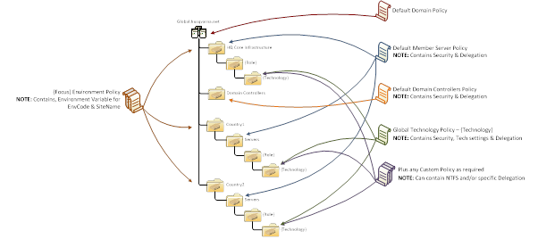

Group Policy Administration
Group Policy Administration in the GLOBAL environment will be performed exclusively via Advanced Group Policy Management.

Management of Group Policy using the new settings and format available in Windows Server 2012/R2 must use the GPMC from Windows Vista or Windows 7 (using the Remote Server Administration Tool) or Windows Server 2012/R2.
Within the HUSQVARNA global environment, the following architectural directions apply:
- All group policy management must be performed via AGPM
- Use of ADMX is strongly recommended; ADM is a legacy technology that adds significantly to risk of a SYSVOL service interruption, and increases to SYSVOL recovery timeframes. ADMs must be avoided.
- All group policy administration is to be performed from a computer running Windows 7, Windows Server 2012 R2, or above. No group policy administration is permitted from prior operating systems.
The below table explains the roles of the AGPM and explanation about each roles.
Role Name | Description
Administrators | AGPM Administrators can perform any task in AGPM. AGPM Administrators can configure domain-wide options and delegate permissions to other Group Policy administrators.
Approvers | Approvers can deploy GPOs to the production environment for a domain. Approvers can also create and delete GPOs and approve or reject requests from Editors. Approvers can view the list of GPOs in a domain, view the policy settings in GPOs, and create and view reports of the policy settings in a GPO. They cannot edit the policy settings in GPOs unless they are also assigned the Editor role.
Editors | Editors can view the list of GPOs in a domain, view the policy settings in GPOs, edit the policy settings in GPOs, and create and view reports of the policy settings in a GPO. Unless they are also assigned the Approver role, Editors cannot create, deploy, or delete GPOs. However, they can request that GPOs be created, deployed, or deleted.
Reviewers | Reviewers can view the list of GPOs in a domain, create and view reports of the policy settings in a GPO, and perform GPO comparisons. Unless they are also assigned the Editor role, they cannot edit policy settings in a GPO.
The below snapshot explains the AGPM process flow for the GPO’s
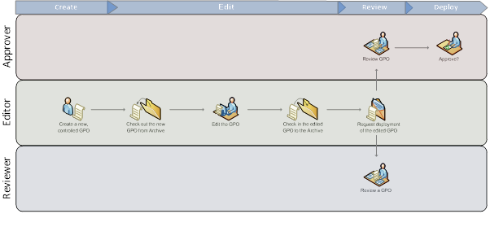

PKI Design

Background

Public-key cryptography (also called asymmetric-key cryptography) uses a key pair to encrypt and decrypt content. The key pair consists of one public and one private key that are mathematically related. An individual who intends to communicate securely with others can distribute the public key but must keep the private key secret. Content encrypted by using one of the keys can be decrypted by using the other.

The public key infrastructure concept has evolved to help address this problem and others. A public key infrastructure (PKI) consists of software and hardware elements that a trusted third party can use to establish the integrity and ownership of a public key. The trusted party, called a certification authority (CA), typically accomplishes this by issuing signed (encrypted) binary certificates that affirm the identity of the certificate subject and bind that identity to the public key contained in the certificate. The CA signs the certificate by using its private key. It issues the corresponding public key to all interested parties in a self-signed CA certificate.

From the PKI perspective, the key design points are as follows:

- Two-tier CA hierarchy – Root and Issuing CA’S
- Offline Root CA hosted on a physical server with no network connectivity
- Two online Enterprise Issuing CAs hosted on virtual infrastructure
- AD CS integration with CA Private Key operations
- Certificate Revocation List (CRL) and OCSP methods for PKI Clients to validate certificate status
- Creating Certificate Templates at the time they are required by the Global PKI service consumers and based on consumer specifications
- Provision of CRL and OCSP services within the DMZ to allow DMZ clients to perform certificate validation

DEPENDENCIES
- Actively participate in periodic steering committee/ review meetings – review progress as well as intervene to facilitate resolutions
- Need to nominate a PMO Team from Husqvarna
- Ensure Husqvarna / Vendor SME time is provided. HCL will take all efforts to provide this requirement in advance.
- Husqvarna will allow HCL to use their office facilities and premises (e.g. seats, desk phone, desk LAN or Wi-Fi, meeting rooms, cafeteria, etc.) during Legacy Domain Consolidation.
- Physical and logical access for HCL has to be arranged during this phase to ensure smooth knowledge transfer.
- Husqvarna to complete internal communication immediately to respective stakeholders post Effective Date
- Review and approve any additional logistics and swing requirements highlighted by HCL

Test cases and Acceptance
Following high level test cases criteria and respective acceptance delivery

- FRANCE <FRY.LAN> and UK <FLENTDOM.LOCAL> site domains to be treated as Pilot sand termed as test case for planning and replication to rest site with lesson learnt
- HCL to create detail test plan for migration of Legacy AD to Global domain for Sweden site agreed domain
- Migration plan to be aligned with respective Husqvarna application owner for in scope server in these two site
- Post approval on planning and approach, HCL to proceed for Migration of these two domain
- Once legacy AD move to Global domain for test domain, proper functionality check to be conducted by Husqvarna application owner and user for Global AD login termed as UAT
- Post successful move, Husqvarna application and other aligned stakeholder to review results
- UAT successful for pilot test domain to be treated as acceptance to proceed for rest migration with aligned lesson learning and design update
- Post UAT and successful migration of rest domain aligned in one country, similar replica to be enabled for rest domain and country with aligned lesson learning time to time

RACI
Pre-Migration Activities | Husqvarna | HCL
Prepare Migration Checklist for Pre, Execution and Post phase | C/I | R/A
Prepare Migration SOPs on basis of executed test scenarios | I | R/A
Prepare Technical Design/Planning Document for each Domain/Forest | C/I | R/A
Configure ADMT tool for migration | C/I | R/A
Review of test results by Husqvarna team after successful migration of users in the Lab | R/A | I
Domain/Domain/Forest specific User, Groups and Object list for Merge using ADMT | C/I | R/A
Security translation on all Servers | C/I | R/A
Domain specific Server hardware assessment & compatibility list for Migration | C/I | R/A
User notification/communication | R | R/A
Domain specific assessment report for Migration | I | R/A
Domain/Forest specific Technical Design Document with Migration approach | C/I | R/A
Active Directory – Deployment Activities | Husqvarna | HCL
Windows Server hardware Procurement as part of ARF | C/I | R/A
Windows Operating System installation on physical Servers | I | R/A
Promote the servers as Additional Domain Controller in to Global AD Domain. | C/I | R/A
Reconfigure the DNS and DHCP structure. | C/I | R/A
Merge of all the Users, Groups, Permission and Objects in to Global AD Domain. | C/I | R/A
Check required permissions for Migration Account | C/I | R/A
Create service accounts and reconfigure applications to use them | C/I | R/A
Migrate Servers and associated Service Accounts | C/I | R/A
Update DHCP Scopes to use the new Domain Controllers | C/I | R/A
Once all users are migrated, update permissions on File Servers, Application Servers, Print Servers etc. removing entries for old objects | C/I | R/A
Schedule the list of servers to be migrated | C/I | R/A
Communication about the Migration schedule to local IT helpdesk team or End user | R/A | R/A
Security translation of File and print servers | C/I | R/A
Verify migration log | C/I | R/A
Fix any issue (login, domain authentication, profile, permission etc.) which is reported by user related to migration of Domain | C/I | R/A
Fix any issue (Replication, DNS resolution, DHCP etc.) which is reported by Domain/Forest related to migration of Domain. | R/A | R/A
Active Directory – Configurations | Husqvarna | HCL
Defining the domain structure and determining server properties | C/I | R/A
Creation and Modification of Sites and Site Links. | C/I | R/A
Ensure the replication convergence for all DCs. | C/I | R/A
Setup DFS or DFSR if required | R/A | R/A
Configure and install AD integrated DNS services. | C/I | R/A
Reconfiguring DNS structure as per design document | C/I | R/A
Reconfiguring DHCP structure as per design document | C/I | R/A
Check all setting as per LLD document like security setting etc. | I | R/A
Ensure the replication convergence for all DCs | C/I | R/A
Check DNS replication in newly promoted domain controller with existing DCs | C/I | R/A
Check stub zone is replicated properly with new DC. | C/I | R/A
Reconfigure all DNS setting for NIC on Each DC ( it should be mapped with new DC) | C/I | R/A
Decommissioning | Husqvarna | HCL
Decommission old Domain Controllers / Degrade of Old Domains | C/I | R/A
Remove DNS records for old Domain Controllers | C/I | R/A
Support Post migration issues if any | C/I | R/A

Appendix
The attached documents covers the Domain Level preparation, Server level checklist; Application checklist and migration sign-off document.

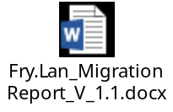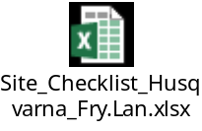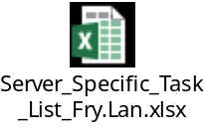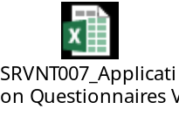
------------------End of Document--------------

